THE TEXT


You almost miss it.

Your phone buzzes while you are watching a TRW training video. You nearly don't check.

But you do.



It is Linda.

"Hey, do you have time to grab coffee this week? I just need to pick your brain about some marketing stuff. Nothing major, just a second opinion on a few things."

You read it twice.

Nothing major.

Three years ago Linda opened her studio with second-hand equipment and whatever was left in her savings account.

You watched her do it. The evenings. The weekends. The first year where she basically did not exist outside that space.

She built it into something real.

She does NOT ask for second opinions.

She also does not text at 9pm about things that are nothing major.

You type back: "Saturday morning?"

She responds in under a minute. "Perfect. I'll make coffee."

Under a minute. She was waiting.



Saturday. 9am.

The studio smells like clean rubber and eucalyptus. Linda makes you coffee and sits across from you. No small talk.

She pulls out her phone and slides it across the table. The motion of someone who has been waiting to show you this for days.

You look at the screen.

Instagram analytics. 847 followers. Posts going back two years: equipment shots, motivational quotes, a New Year New You promotion from January. It is May.

Average likes per post: 12.

Comments: almost none.

One comment is from her mum.

She watches you look at it.

"I have tried three different strategies," she says. "Posting every day. Hashtag research. I ran a Facebook ad, two hundred dollars, got two people. Did a referral card thing. A Bring a Friend month."

She picks up her coffee. Sets it down without drinking it.

"We are at 34 members today. We were at 51 eight months ago."

The room is very quiet.



She looks out the window at the empty street.

"I think maybe I just need to figure out the right platform," she says. "Like... should I be doing TikTok?"

You look at your friend.

Your friend who has not touched her coffee.

Your friend who texted you at 9pm.

You feel the pull to just answer her. TikTok. Sure. Here is what to post. Trending sounds, short clips, three times a week, go.

But something stops you.
________________________________________________________

🛑 THE WALL 🛑

Every strategy Linda has tried has failed.

Not because she executed badly. She put in the work.

The problem is deeper than all of that.

And if you cannot name it right now, you are going to do exactly what every other person in your position does: blindly recommend a new tactic.

Something easy to imagine. Something that sounds like progress.

But six months from now, all Linda will have is a new list of things that did not work.

You feel the pull to just answer her fast.

You need to resist.

Question 1/2
YOUR GUT CHECK

Your gut is telling you something. What is it?

She has tried multiple platforms and tactics. The results are consistent: nothing works. Before you say anything, you need to diagnose the real problem.

What is actually going wrong here?

- She does not actually know who she is trying to reach, so no message she writes can hit the mark

- She has been inconsistent and algorithms punish accounts that go quiet between campaigns

- She just needs to commit to one platform and go all in rather than spreading her effort

- Her content looks and sounds like every other studio in the area, which makes it easy to scroll past

CORRECT ✅
Answer no: 1
That's it. If you don't know who you're talking to, it doesn't matter what platform you're on or how good your content looks.
Every message is just a guess.

You're about to learn exactly how to fix that.".

______________________________________________________________________

"Linda, I do not think it is the platform," you say.

She looks at you.

"Before we talk about where to post or what to spend, I need to understand something. Who are you actually talking to?"

She blinks. "What do you mean? Women who want to get fit. Local women, mostly."

Something settles in your mind.

That is the problem. Right there.

You just need to be able to explain why.

Below is our Professor Andrew’s Comment:

“THE MOST IMPORTANT TRUTH IN BUSINESS

All right, here's what's broken.

Linda is making the same mistake and is basically every business owner on the planet.

Let me show you how to think about business and marketing your way. Turns out, that's where you actually make some money.

And you don't just do marketing.

You actually get customers to decide to buy it from you.

You have to understand from the ground up.

Let me show you.
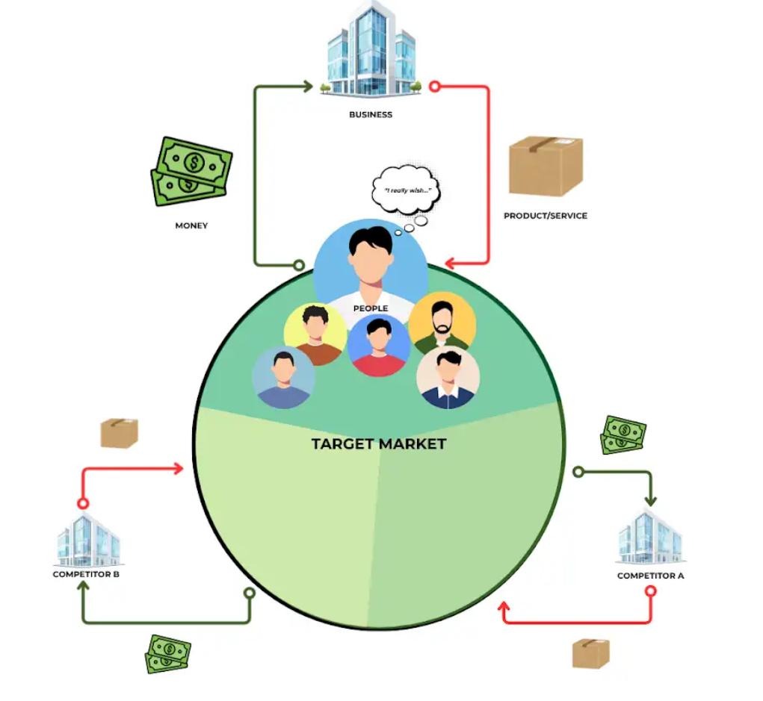
So, you have to understand that people exist.

Humans are out there on the planet.

There is a whole bunch of them.

You might have seen some as you go through your life.

There are human beings on this planet, and human beings want stuff, right?

People out there have desires, they have things they don't like about their life.

They have desires they'd like to achieve, dreams, goals, et cetera.

We'll do a deep dive on this in one of the future lessons here.

But humans exist and humans want stuff.

Now, humans don't just exist and want to have been isolation.

Whenever there's a bunch of people that want something, a business will show up.

Somebody will show up and offer to help that person get what they want by providing a product or a service for them.

So, in this case, you know, we've got Linda, who has, there are people out there, these, we're gonna learn more about them, but there are people that want to achieve certain dreams and goals in their life.

And Linda shows up and she offers a product or service in the form of her gym membership.

You can think about, there's lots of different products and services.

You can go buy an airplane, you can buy food, you can buy information, you can buy entertainment. A whole bunch of different products and services.

The businesses create and give to people who want stuff.

Now, if they present this product and service in a way that matches up with what these people actually want, well, then the people will pay the business money.

Now, I know this is very foundational stuff, but it's wild how many business owners get this wrong.

They look and they say, I'm a business, I do stuff.

Let me just do stuff, and then people will show up and pay me money, but that's not really how it works.

As a business, you need to find people that want things, you need to know what they want, you need to know what they, how they judge, whether something is valuable or not.

You need to know a whole bunch of stuff about these people.

You need to provide products and services and communicate those things to these people in a way that resonates with what they think and want.

And as a result, they'll decide to pay you money.

If you just do marketing and provide product and services that no one wants, Well, you're not gonna make very much money.

So the whole point of business, and really, uh, something I want you guys to think about here quite a bit, is this idea of the, the, this little red arrow here actually kind of represents a lot.

So this red era, the way that the business shows up and talks to the customers, is marketing.

That's what we do, the way we get their attention, the way we show them our product and service, show them how it matches up with what they want.

And that is our job.

That's what we're gonna help businesses do.

We're gonna do so in a way that doesn't just work on one person at a time.

We're gonna work, we're gonna do it in a way that works with a bunch of people at a time, because whenever most businesses don't just serve one, one person, there's usually a whole bunch of people who all want roughly the same thing.

And if this group of people all roughly want roughly the same thing, that's called a target market.

And this target market, the better you are at getting their attention, the better you understand them, the better you know how to speak to them and influence them, and show them your product and service, and convince them to buy the better you are, that the larger the chunk of the larger the chunk, you're gonna get of the target market.

You know, there's maybe, in Linda's case, there's probably tens of thousands of women in that area that are gonna match her target market.

And the better you could, reach out to them and get their attention, the better you can speak to them, the better you can position her studio.

The more of then you'll get to show up and pay her money.

Now, one thing to keep in mind, before we get too carried away with ourselves, is that businesses don't really exist in isolation.

There's usually a bunch of other business, whenever there's a lot of people that all want something, different businesses will show up, competitor A, competitor B, will show up, and they'll try, and also market, get their product and service out to this target market.

And it becomes a little bit of a competition.

So not only do you need to understand your target market and what they want, but you need to understand other businesses on the planet and how to stand out.

You need to know how to show up and understand them better, because you know which business is gonna win the biggest chunk of the target market here?

It's going to be the one who understands the people, who understands the actual individual target market, the best, and then runs their marketing in a way that gets their attention better and convinces them to buy better.

Most business owners, thankfully, are retarded.

And you just show up and spew out marketing, don't just computation, everybody does.

I'm going to show you how to understand it, but you want it, no matter what industry you get involved in.

I'm sure you had to understand the target market, how they think about their problems, how they evaluate choices, and how to plan a way to get in front of them, grab their attention better than everybody else, and communicate to your value better than everybody else, and so they will pay you and your business, or the ones you partner with, more money than everybody else.

That is marketing in a nutshell.

The rest of the course is gonna be me teaching you how to basically make this diagram a reality. Helping you show up hard with businesses, understand the target market, position products, and services where they gets the most attention, it gets paid the most, money.

This is the game.

In our story, Linda has shown up, and she doesn't understand her target market very well.

She's just doing marketing stuff, it's not working out for her.

There are, like, millions of businesses on the planet that are making the same mistake.

I'm gonna show you how to help them and any other business show up, understand the target market better, get their attention better. And get them to pay them more money.

That's how you're gonna make millions using this program. ”

Question 1/2
KNOWLEDGE CHECK

Linda says her target market is "anyone who wants to get in shape."

What is the core problem with this framing?

- It works fine as a starting point and can be narrowed down once the campaign is running

- It tells you nothing about what they feel, what they fear, or what is standing in their way

- The language is slightly off-putting because "get in shape" carries a negative implication

- It is too broad, making it hard to choose the right platform or set a sensible ad targeting budget

CORRECT ✅
Answer no:2
A target market definition that skips the emotional layer gives you nothing to write with.

You need to understand how these people feel, what is blocking them, and what they wish their life looked like.

That emotional layer is what you are going to spend the rest of this act learning to find.
_____________________________________________________________________



Linda sits back.

"Okay," she says slowly. "So we do not actually know who we are talking to."

"Not yet." You pick up your coffee. Finally. "But we are going to find out."

For the first time this morning, she almost smiles.

The Uncomfortable Question


You need to understand who Linda's best customer actually is.

A real person. Someone Linda could describe in one breath. Someone whose life you could almost picture.

You ask her: "Who is your absolute best current member? The one you would clone if you could?"



Linda does not hesitate.

"Sarah."

Mid-40s. Works in healthcare administration. Two teenage kids. Came in for the first time looking like she had not slept properly in months. Now comes four times a week. Has referred two friends.

Linda pauses.

"She cried in the locker room once. Then apologized to me for it."

You ask: "What was Sarah's life like right before she joined?"

Linda thinks. Really thinks.

"She told me she had been running on empty for years. She kept putting herself last. And she said she almost did not come in because..." Linda stops. "Because she felt like she was not the type of person who did pilates."

You write that down.

Felt like she was not the type of person who did pilates.



🛑 THE WALL 🛑

You're starting to learn more about the target market and what they want.

But Sarah is just one person.

Which means right now everything you think you know about Linda's market is based on a sample size of ONE.

If Sarah is representative of other people, the whole strategy works. But if Sarah is an outlier, the whole strategy is built on a story that does not apply to anyone else.

You need to find out if Sarah matches the rest of your target market.

Linda is looking at you. She wants a next step. Can you give her one before you have confirmed anything?

Question 1/2
WHAT ARE YOU MISSING?

What is the most important thing you are still missing?

You know Linda's best member. You know her story. But you need more than one data point before you can build a marketing strategy around it.

What do you need most right now?

- Exactly what happens in each class, the history of Pilates, and how it's different from Yoga.

- More information on how this market thinks, what language they use to describe their desires and pains.

- The demographic profile: age, income, location, what platforms she uses.

CORRECT ✅
Answer no:2
Right. Demographics tell you surface-level facts.

What you actually need is to understand how these people think, how they describe their own frustrations, and what language they use when they talk about what they want.

That is the raw material you will write with.

Below is our Professor Andrew’s Comment:

“HOW PEOPLE THINK ABOUT THEIR PROBLEMS

Last lesson we talked a lot about this diagram.

We talked about how your job as a marketer is basically to show up and help businesses get attention from the target market and convince them to buy.

And we, I mentioned several times that the business, the business that wins the competition is the business that understands the target market the best.

Now, there's a common trap that a lot of business owners, a lot of marketers make, write it around this point.

And that is, they focus too much on demographics and not enough on psychographics.

Now, those are two really big words.

Let me break them down for you.

The first one, demographics, is knowing, like, the age or the gender or the education level of somebody.

Like, in this case, Linda, she targets women between 25 and 45, who work a busy job or something like that.

That's the demographics.

And it's good to know roughly, you know, what type of person is gonna be in your target market.

But knowing that someone is a 40 year old professional doesn't necessarily allow you to grab their attention very well.

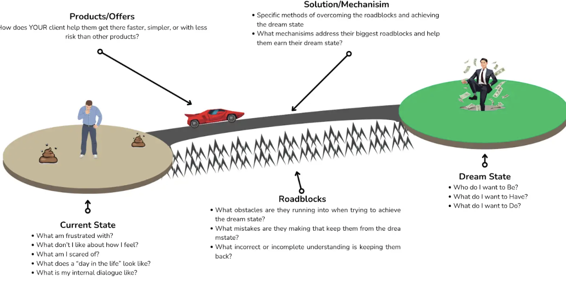

What you need to understand is their psychographics, not just kind of what their number is on their driver's license, how old they are, but you need to understand how they think about their problems, how they think about their desires, how this plays out in their brain.

Now, thankfully, human beings, while our problems are very different, and our desires, and our dreams, and our current situations, are very different, the way we think about our problems, and the way we think about our current frustrations is actually very similar.

There are a couple of key elements that if you understand them, these psychographic elements, if you understand how your target market thinks about these people, well, it's gonna give you an advantage when it comes time to market to them.

You will be able to actually speak to, not just their demographics, but what they're thinking about. Psychologically what's going on in their brain.

So I'm going to show you the categories, the ways that people think about their frustrations and their problems and the solutions and the products they buy and how all these things are connected.

So once you understand them, you'll be able to go out and find this information and use it to market, land a bigger chunk of the target market, and outcompete anybody in your industry.

So, let me show you the different categories.

So, let's start off with the current state.

So every person, kind of right now in their life, is in a situation.

And the deal is, most people don't really like some things about where they are.

Now, we're all grateful and nice, and we like to have, we like to appreciate the things that we have, and our lives is terribly depressing, but generally speaking, there are things currently in your life that you do not like.

And this is the same for all customers.

Now, as I go through and I show you these different categories, you have to remember, most people won't think about their life in these terms, at least not consciously, but subconsciously, they understand and evaluate their choices through these different categories.

So, there's the way, like, an element, the element of psychographics that we're talking about right now is the current state.

The way that your person, your target market person, thinks about their life, specifically what they're frustrated with, what they don't like about, how they feel, what they're scared of, kind of what their normal frustrations are, what does their internal dialogue look like?

Where are they sort of right now?

That is the first part.

And usually, this is sort of the current state, the pain state, the frustrated threatened state.

You need to know how your target market thinks about.

They're like, currently, how they talk about it, how they describe it to a friend, how they think about it in their mind.

When they stub their toe or run into whatever problem that you help them solve, what it immediately goes through their brain or their actions, you need to take some time on the tent.

And guys, I'm gonna give you, over the course of the next few videos, a bunch of cheat codes to get this information from the target market so you can show up a market better than everybody else.

But step number one is you need to understand their current state, and you need to also understand their dream state.

So nobody is just, man, my life sucks.

Or, man, this is my current life.

Everybody has a dream state, a version of their life, at least across these different modalities of their life.

They have a dream of how they would like things to be.

They don't like things over here.

It's terrible.

It states.

They want to live a better life.

They want to have better outcomes.

So what do they want to be?

What do they want to have?

What do they want to do?

Now, you can look at this, like, overall, in their entire life, but, generally speaking, you're gonna look at this through the lens of whatever your business does.

Like, if your business helps them, I can lend this case to get better help and better, feel better.

You're gonna focus there. Not really gonna care about their financial side of life or whatever.

But you want to analyze and think this aspect of this, their lives.

I think that they're frustrated with and I think that they're trying to achieve their goal over here.

What isn't?

How do they think about it?

How do they describe it?

What do they want to be?

How do they want people to view them once they have this?

You need to understand their desires, what they're moving towards.

Now, here's the deal.

As people try and move towards things, like this guy over here, everybody, when we wake up and we have a problem and we have a goal, we'll try and just get it ourselves.

Like, this guy will try and, like, walk his way over to the dream state, but he'll reach the edge of the cliff here, and he'll run into the next little issue, which is the roadblocks.

In between your current state and where you'd like to be.

Between where you are now, where you'd like to be, there are all sorts of little challenges you're gonna have to overcome.

These little roadblocks that keep you from getting there.

Little problems you have to solve, little challenges you have to overcome, little things you have to learn, or ways you have to go about solving the problem.

And if you don't know about them, it'll keep, and you don't know what they are, don't know how to solve them, well, you can never reach your dream state.

You'll never reach that goal, because this little problem will defeat you.

So, these roadblocks, these obstacles, you need to know what they are.

Now, sometimes, this guy will actually be able to, like, list out all the problems or keeping them from achieving his goal.

You know, maybe the case, these women might be aware of some of the challenges that are keeping them from having their dream state of, you know, feeling good and moving and not being sad anymore.

But also, a lot of times, this guy won't even understand it.

He'll try and get his goal, and for whatever reason, he can't get it.

And there's an unknown roadblock.

So some roadblocks are no, and some are unknown.

Think of people that are trying to, like, that are FASOS and are trying to lose weight.

They're trying to be lean and mean and have a good time.

But, uh, they, no matter how hard they try, they can't seem to lose the weight.

Well, they might not know about calories.

They might not be, they might not know about, you know, this form of training or left in, or these different challenges or roadblocks for keeping them from what they want.

But you need to identify, in their mind, what things are keeping them from getting there, and then the things that maybe they don't know about, the mistakes that they're making that they're unaware of, that are keeping them from getting their dream state.

That's the third category.

Again, just as a reminder.

Very rarely do people have these things all listed out in their lives.

Generally speaking, this all happens subconsciously.

You need to understand it consciously so you can speak to them.

The other element is the solution.

So, remember how I talk about how when people watch stuff and businesses will show up and produce a way to help them get that thing?

Well, this is kind of related to that.

There's all of these problems and roadblocks that are in between them and what they want.

There is a solution to it.

There's a way for them to fix this problem, address this problem, get to what they want.

There's a way, a solution, a mechanism, affording the case here, these women, like Linda, she helps these sad, sad, isolated women, move their body, feel social, get some endorphins, and feel meaning in their life.

The way that she solves all of their problems and come from sitting around, being isolated, feeling sad, and all that stuff is by helping them do Pilates.

Now, theoretically, they could do Pilates in their living room and get a lot of the same benefits, right?

But the idea of doing Pilates is one solution.

Now, generally there's multiple solutions to different problems.

They could do yoga, which would be sort of another bridge here, or they could take SSRIs or whatever.

There's different things they can do, theoretically, achieve the dream state in different ways.

There's different potential solutions.

But you need to identify what the specific solution is, that your, especially your business, brings to the table and help this person now be able to go all the way over to their, to their sort of dream state.

You need to be able to identify that and understand what about your solution helps them solve those individual roadblocks as individual challenges.

It's good to know what the other ones are.

Now again, this guy, he might be aware of this potential solution.

In this case, this woman, uh, in the Linda situation, she probably knows about Pilates, but maybe there's some women who don't know about Pilates.

You need to know what your target market, the people that you pick to go after.

You need to ask yourself, like, what solutions are they aware of to give their dream outcome, which they tried already?

What did they think about those solutions?

You need to be able to list those things down.

And the other element here are the specific products and offers.

So, there might be a dozen Pilates studios in Linda's area, in this story.

There might be a bunch of different businesses that use the same solution, a similar outcome to people that can go to the body studio on this street.

They go to the body studios on that street.

There's different products or different offers or different experiences that they can get that all use the same solution.

Now, the business, or the target market here, he will, or they will, whoever we're talking about, they are gonna evaluate and pick the best product that allows them to get through their dream safe, the fastest, the easiest, the best experience, the most affordable.

They're going to evaluate the product based on what their preferences are and every target market has their own little preference.

But they're gonna evaluate each individual product and decide which of all the available products is gonna help them achieve their solutions.

You know, implement the solutions and achieve their dream state.

So, when you're looking to understand your target market, you don't need to just know how old they are or, you know, and that's gonna vary a lot.

Usually with your target marker, what matters most is you understand the pains that they all share, the dreams that they're looking for, the roadblocks that are keeping them there, the available solutions and how they think about them, and the different products on that solution, and how they think about those.

If you understand all of this information, and I'm gonna show you how to get their exact words, how they literally speak and talk about this, how they actually think about it inside the brain.

I'm gonna show you how to go through and find all of this in the near future.

But when you understand this, you're able to show up to a market, you're able to show up to these people and speak to them.

You're able to present your product and service.

Hey, wait a second, that's on the other diagram, too.

You're able to show them these things in a way that grabs their attention.

You're gonna be able to speak in a way that's relevant to them.

You gonna be able to address their actual, We can go back to this other tab real quick.

You're gonna be able to, where did it go?

Here it is.

You're gonna be able to speak to them about their current state in a way that shows them that you understand them.

You're gonna be able to offer the outcome in their own words in a way that they think, that's exactly what I freaking want.

You're gonna be able to talk about the roadblocks that have kept them there, maybe show them the new ones, or talk about the old ones that have, oh, would stop them, and you're gonna show them what your solution is different, why your product or offer is different.

Being able to understand these terms, the way that they think about it, is what's gonna allow you to put together the marketing assets, the ads, the pages, the offers, the communication, the sales calls, the experiences when they first walk in the door.

You're gonna be able to craft all of these to match their internal way of thinking about this, where they pick your product every single time.

You have to understand these categories.

Everybody thinks about their problems in these same terms.

Once you understand how your target market understands this, it gives you a huge leg up over everybody else that's trying to sell them anything.“

Question 2/2
KNOWLEDGE CHECK

Sarah told Linda she "felt like she was not the type of person who did pilates."

Why is that specific phrase more useful to you as a marketer than knowing Sarah is a 44-year-old healthcare administrator?
- It reveals an emotional barrier that other potential customers probably share, which gives you something real to write to

- It tells you Sarah has low self-confidence, which means the marketing should focus on building people up with motivational messaging

- It tells you Sarah's age group doesn't respond well to fitness marketing, so you'd need to target younger demographics instead

CORRECT ✅
Answer no:1
That phrase is a psychographic signal. It tells you how she sees herself and what almost stopped her from walking through the door.

If other women feel the same way, you have discovered the emotional barrier your marketing needs to address.

You will hear an even sharper version of this in Act 2 when you talk to the real people.

__________________________________________________________________

"We know Sarah," you tell Linda. "But we are basically guessing that every great potential member feels the same way she did. Before we write a word, we need to find out if that is actually true."

Linda nods slowly. "So what do we do?"

"We need to learn more about them before we can say anything useful to them. And some of that learning we can do before we talk to a single person."

Linda looks uncertain. "How?"

"I'm going to start digging..."

The Market Walk


Sunday. You make coffee. Open the laptop. Pull up the market research template.

Five categories staring back at you. Current state. Dream state. Roadblocks. Solutions. Products. All empty.

Your job today is to fill these in. Not with your guesses. Not with what you think these women feel. With what they actually say. In their own words.

You need to go find those words.

🛑 THE WALL 🛑

You have a rough idea who you'll be targeting with your marketing but only sparse information on how they think about their situation.

You also have no idea what Linda's competitors are already doing and how she can stand out.

You need two things: the market's voice and the competitive landscape. The gap between those two is where the opportunity is.

But how are you going to find all of that?

Below is our Professor Andrew’s Comment:

“MARKET RESEARCH

All right, so we know that we need to understand the target market if we want to be able to mark it well to them if we want to catch their attention if we want to get them to buy from us.

We know what we need to find out about them.

We need to know how they view their current state, what their dream state is, what roadblocks are keeping them from getting there, what solutions they're aware of, how they evaluate them, with products, how they evaluate this product or this business versus another.

We know what we need to know, we know why it's so important, but it's gonna allow it to communicate, better your target market, get them to buy from us.

We also, we want to figure out how to do so better than the competitors.

We kind of know what we need to go look for.

Now, I'm gonna give you many ways to find out this information to find these answers, but let's talk about the two biggest ways you should start with, which is, you need to do two types of very basic online research before you get to into creating your product or creating your marketing campaigns, writing out the actual stuff.

You need to go out and do a little bit of basic intelligence gathering looking online to see how your target marketable talks about this and also what your competitors and other businesses are doing to catch their attention, what's working well.
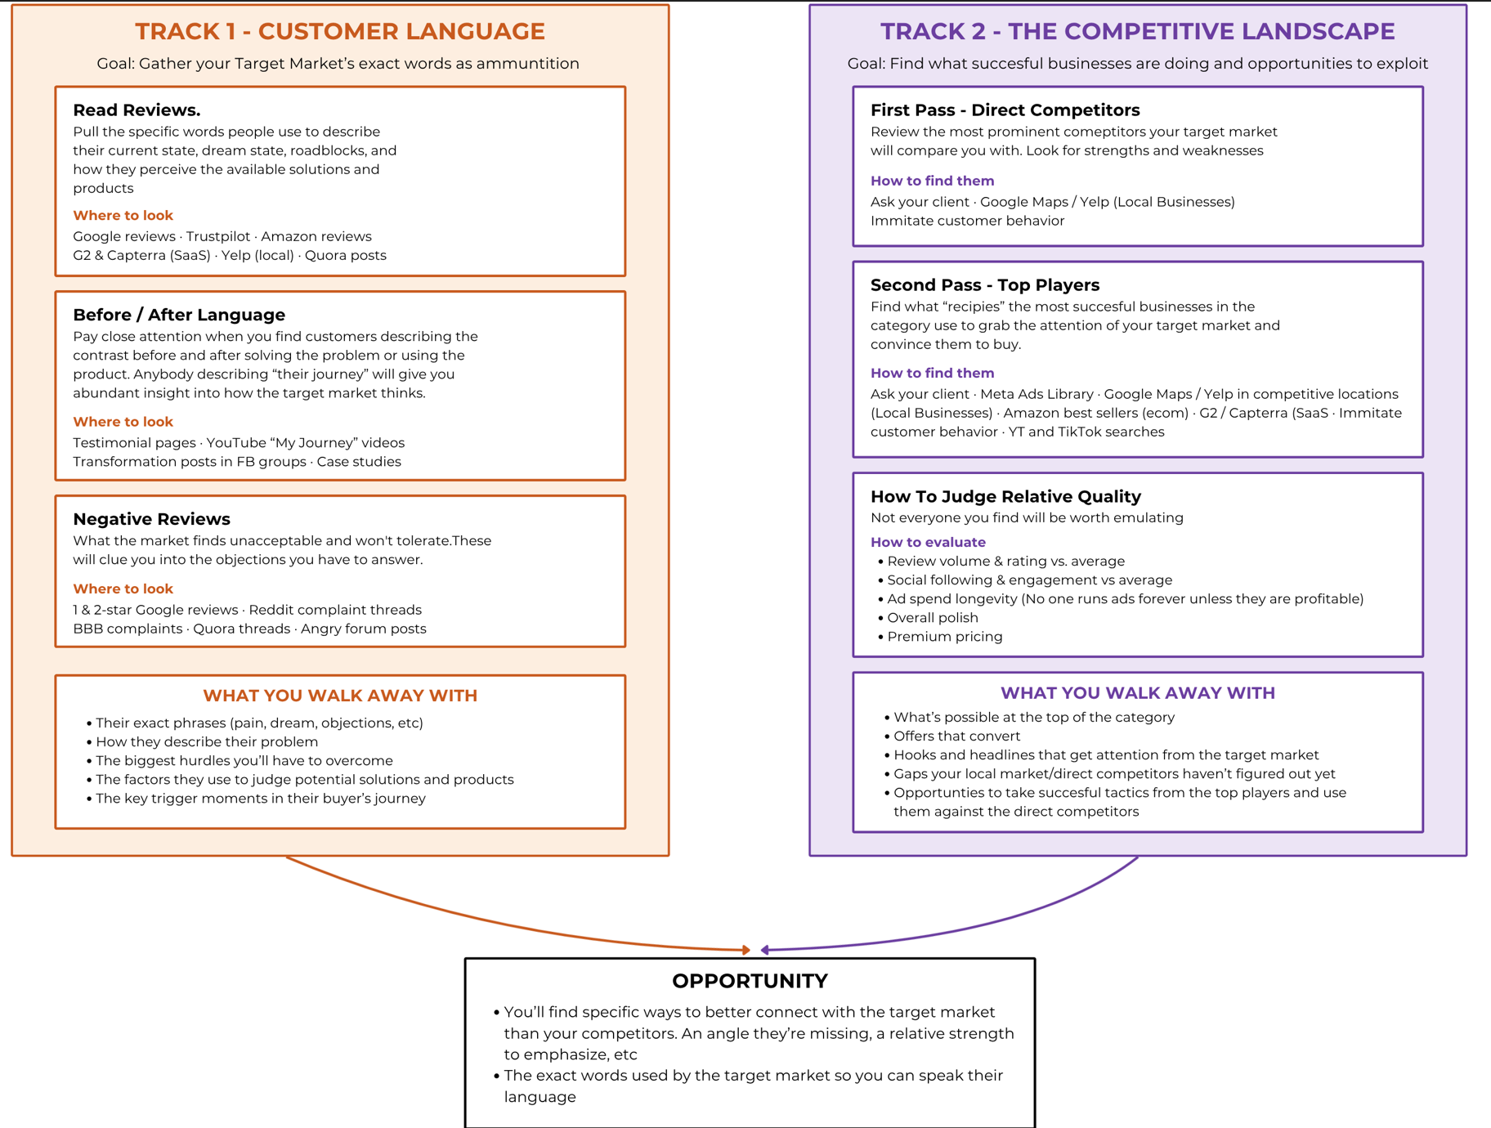

And between these two different pathways, you're gonna start finding opportunities for the business that you're working with to show up in a unique way, capture attention from the target market, and close a lot more.

Does make a lot more money.

So, let's walk through these two different tracks, these two different basic forms of research, and there is a little bit of an overlap between these two.

We'll go through how you go to find some of these answers online.

As a starter, there are other ways you can get even more advanced information by the target marker, which I'll teach you soon.

Let's take a look at the first two.

The first one, and this is the most important, is you need to understand your customer and how they speak and think about their problems.

We already mentioned this, the dream state roadblocks, current state. Solutions, product, with that big diagram.

But let me show you where you can go and start to get some inclination as to how they actually do this.

Number one, the first place you want to look is, you want to go read reviews.

And you're gonna start with the reviews of the business that you're working with.

You're gonna look at the five star reviews, the four star reviews, all the reviews, and see, see what information they share about themselves and their experience using the product.

Now, this is gonna give you some information.

Let me show you on the other diagram, how this plays out.

So if you read a review where someone says, yeah, I showed up, and Sally was so nice, and I had such a great experience there, and I felt really energized.

I highly recommend this business.

Well, that's gonna tell you a couple of things.

One, highly energizes the outcome they got, the good thing that they liked.

Congratulations, we now know one way that they describe their dream state.

And if they say, Sally was so nice, we know that they like to evaluate the products based on how kind the actual staff are there.

We've got two little pieces of clues that we can use to understand how the target market might be thinking about their products, or thinking about their problems and their desires.

I'm gonna be able to put that into our market research template, which is attached below here, and be able to start collecting these things.

And as you continue to read reviews, you might start to know certain patterns.

They all sort of describe the dream state this way.

They all sort of describe how their life was before this way.

They kind of talk about the same thing, about how much they like this product.

Maybe that's something that they really care about when they're going to evaluate this.

Anyways, you're gonna go through, and you're gonna read reviews to harvest this information.

Not every review is gonna have a lot of valuable information, but the more reviews you read, both of your business, local competitors, other businesses like this on the planet, the more clues you're gonna start to get.

Another thing you should really look at are anywhere where you see before and after stories being told.

So sometimes businesses will have these other websites, they'll show their clientele before, and then after, and they'll tell the story.

Anytime they tell you the story, well, that's basically them telling you this entire thing.

So and so started off, they look like this, and then they look like this.

They overcame these roadblocks of dissolution, this product.

You're gonna be able to get a lot of information from that.

Also, anytime someone tells their journey to achieve a goal, they're gonna mention basically everything here.

It's one of the richest places you go to find this information.

Like, if you go to YouTube, and look at someone telling their story, how they start it ends, or how they finally achieved why.

They're gonna tell you all the things they didn't like about them.

They're like beforehand, why they wanted this thing, how they started, the solutions they tried, what worked, what did, what things, what mistakes they were making, and how they actually decided to buy it.

Going out and looking at the before and after language is one of the best ways, one of the best ways to get information about how your target market thinks about this.

So you're gonna go watch on YouTube, and there's transformation posts.

You can go look at these communities online where people talk about this.

There's a lot of places to go poke around and find this information.

The other thing you want to look at is you want to look, and not just, like, the positive reviews, but you want to look at the negative reviews.

Negative reviews are a gold mine, because whenever a business, or whatever, a person buys a product or tries a product or service they thought was good, and it turns out not to be good, they'll tell you all the reasons it wasn't good.

They'll tell you things like, why the product wasn't as good as the other things they had tried.

They'll tell you what they didn't like about that specific product or why that solution didn't work for them.

And you'll start to give these little clues about how the target market actually evaluates what product solution is good.

You'll learn a lot of things about that.

If there's something that it didn't give them, a version three, say that they didn't get, that they wanted, they were promised, you also see a lot of that.

Reading the negative reviews will tell you things to avoid, but also will help you understand how people evaluate products and solutions, and elements of the dream state and current state that they might not say in a five star review. When they're talking about how great everything was.

So, looking at reviews is a very good place.

Both positively and negatively, is a good place to look to go and find all this information.

Now, the more you do this, the more you expand and poke around and search and find stuff, the more you collect their language and paste it into your market research, then, but you're gonna start to come up with some patents.

You're gonna start to discover the exact way that your target market describes their pains, their desires, the main objections they have, the key things that made them decide to finally buy.

You start to pick up these little gold nuggets.

And it's gonna help you understand your target market better than everybody else, and what they want. Sort of their desires.

Now, how well, you meet them or what you can use to grab their attention, that's another story, but if you understand what they're looking for, well, that's the very, very beginning.

The other side of the coin here is you need to look at the competitive landscape.

So, if we go back to this business room, let me go back to this diagram and help you understand this.

So with this first track, what we just described, reading reviews, YouTube videos, all that stuff.

We've gone and seen what these people say.

Like, what they say, they like and what their experiences are.

We've got a lot of their own words, which is great.

We now have a lot of understanding of this target market.

The other thing, though, that we can look at, is we can look at businesses that are selling to these people.

We can look at how their marketing, how their communicating, how they're trying to grab attention, and we can use what everybody else is doing to start to gain some clues about how these people think. And to see what's working, what's not working, which will help us find an opportunity to show up, and I'll compete them, we'll find their weaknesses, and we can counter them with our strengths.

Or we can find what other people are doing really well in other markets, and use that, bring that tactic or tool here to stand out from our competition.

Anything that a business is doing to talk to Tar, the target market, that results in them getting paid in a lot of money, means that they have found a way to speak to the target market.

They know something about the target market.

And if you look at what they're doing, you can reverse it near it, take that information and use that.

So, it becomes your advantage as well.

Let's go back to the diagram, and I'll walk you through how I recommend you do this.

So the first thing you're gonna do is you're gonna look at all of the direct competitors.

So in this case, we have Linda, and she's got a Pilates studio in a city.

Now, she's got several direct competitors.

There's a couple other Pilates studios.

Maybe there's a yoga studio.

Maybe there's this gym, there's all these people who are selling to the target market.

And the first thing you want to do is go look at all of their businesses, look at how they're communicating, look at the way they're running their ads, their pages, and stuff like that.

If they have a headline that calls out, uh, you know, Hey, are you tired of, Are you tired of dealing with blah, blah, blah, blah, blah?

And it's working.

They've got a lot of reviews, they've got a lot of customers.

Wow, maybe, yeah, that means that the target market really cares about that thing, that they just called out that pain. They just calmed out.

Or if they offer this dream statement, or they emphasize why their product is good because of the experience or whatever, whatever, you're gonna start to realize what the target market is responding well to.

You're also going to find things a lot of times, especially if you're dealing with, like, a local business like this, you're going to find a lot of local competitors that are successful, even though they have pretty terrible markets.

They'll be kind of just rolling along, and you'll look at it and realize this isn't very good.

We'll get back to that in a second.

They might not talk very directly to the target market or what happened.

You'll see that play out in the story as well.

But you want to look at your direct competitors, you're gonna want to look and see how they're getting in front of people, how they're speaking to them, what they're saying about the, like, to the target market to try and get their attention to convince the divine.

And you're gonna kind of list all that stuff out.

You're gonna look for things that are doing well, but you're all smooth for things that they're doing not very well.

You're gonna look for their strengths and their weaknesses.

Once you've kind of got an understanding of how everybody in your market is talking to their target, to the actual target market, the customers, you're gonna want to do a second pass where you go look at top players.

Now, this is, this can be kind of tricky, so pay attention here.

Let's say, and I'm gonna go back to this diagram to help you understand.

Let's say this target market is everybody in a city.

Like let's say this is everybody in San Francisco that is trying to solve this particular problem.

You're gonna have, you know, you'll be a business that's trying to solve that, but there'll be 20 or 30 other businesses.

Um, in this city, trying to sell to this particular target market.

And there'll be some players here, some businesses that are doing really well and some that are doing very, very poorly.

But generally speaking, there are other clones of that target market across the world.

So, San Francisco, there's a market for Pilates in San Francisco.

There's a market for Pilates in Houston, Texas.

There's one in New York, one in LA.

One in Portland, one in Ontario, one in London.

There's all these different areas where other businesses are competing against each other for our target market, that's pretty much the same.

A target market that thinks about their problems, basically the same as your target market.

Now, if you're in an area, or let's say, you know, maybe San Francisco, for my previous example, was too much.

Let's say you're in Tulsa, Oklahoma, or whatever, right?

Some tiny little part of the world.

And you're in a business, but your other competitors aren't that competitive.

They're not that great.

They're doing okay, they're some people there.

If you go and look, and let's say, L.A. Or New York, where there's a lot of Pilates studios, and they're all really, really competitive, some of those businesses, the people that are winning in the most competitive locations on the planet, they probably have figured out the best way to communicate to the target market.

Like, on the planet, probably.

They probably have done so much understanding and tested so much marking and spent millions on ads, they've tested this, they tested that, they've gone through the gauntlet, competing against everybody in this big place, and they'll probably have understood the target market better than anybody in your area. Or in your particular part of the market.

And you can look at how they're communicating, what they're doing, and use that to figure out some ways that you can then take that strategy, come back, you know, come back from New York, with that strategy, and bam, apply it in Tulsa, Oklahoma.

And boom, you'll be the top dog in Tulsa, because you worked at that strategy.

So, you're gonna want to go take a look at these top players.

I'll show you how to find them, how to look for them, and all that stuff.

Here in a second, let me switch back to this other diagram.

And we'll talk through the top players.

So you want to go out, and you want to look and see what they're using, how, you know, what elements of the dream state, the current state, and pains and frustrations, they're talking about to get their attention.

You're gonna want to see what they're doing to convince them to try them over everybody else.

You're gonna go look and kind of see the recipes that they're using to talk to the target market, to do two things.

A, you're gonna see some cool tactics, you can probably use.

We'll talk more about how to implement those later.

But also, you'll see, you'll start to learn about what the target market is positively responding to, and that's gonna be useful information you can add to your market research, and it'll give you a deeper understanding of your target market.

Now, a lot of people have questions to kind of know, like, how do I know if this is actually a top player?

How do I know if this local business I'm competing with is good or bad?

You're gonna have to kind of estimate.

You're not gonna know every, you're not gonna know with 100% certainty if a business is super successful or not.

You're gonna be able to get there some indicators, though.

So if they have higher, a higher number of reviews than the other businesses in that market, congratulations is probably a, they're probably doing pretty well.

They've got a large chunk of their target market to come and decide to buy from them.

If their social media followings are higher, if they have high relative levels of engagement, now again, you have to kind of compare them against their peers.

But if they seem to have a lot of traction, they have lots of testimonials, they have lots of customers.

That's a good indicator that they have over here.

It's a really good indicator that that competitor has found a compelling way to speak to the target market and get them to one to five.

The more of this, the more proof you can see, the money has changed hand, performed testimonial, size, overall polish, et cetera.

The better you can say, okay, this person has figured out something useful.

I'm going to learn from them.

If a business has less testimonial, less customer, less polished, less indication that money has changed hands, where they probably have a small segment in the market, They're probably not worth emulating too much.

They're probably making some mistakes that you can capitalize on.

Now, your job is to go and find these tactics and apply them, but again, we're trying to understand the target market here, and we're going to look at what competitors are doing, both, that's effective and non effective to learn what resonates well with them, what matches up with their current dream, save their...

Are their current state, their dream state, the roadblocks, et cetera.

So, let me go back to the market research diagram, and we'll walk through this.

So, as you explore this, you're gonna see what's working, what's not working.

You're gonna find tactics to work, you're gonna understand where the target market values.

You're gonna see what they don't value.

And you're gonna file all this away instead of your target market template, the diet, or the template, or the document I give you guys here underneath this lesson.

Now, as you go and look this, you understand more and more about the target market.

You're gonna gain all this information.

You'll be able to speak to them, you'll be using all that as ammunition inside of your marketing assets.

So when you go to write your ads, you're gonna use the language that they give you as, like, you're gonna literally copy and paste some of that into the marketing assets that you make.

You're gonna put that in the video script. Put some of that in the headline.

So you're gonna have a big library of this information.

You're also going to see what's working really well, what the target mortgage is responding to, and either see what's not working really well.

And generally speaking, you're gonna find an opportunity at the state.

You're gonna start to get a hint as to what you can do.

You're gonna find...

I go back over to this, the big diagram over here.

You're gonna start to find something that the target market wants, that no other competitor is giving them.

Let's say, you're in a local area, you can discover that they all really, really want this particular dream outcome, but very, like, your local competitors aren't even talking about it, or you're gonna discover that the top players are making a really, really easy get started with this limited time offer, and nobody in your area is doing that.

And this, you're gonna find these opportunities that you can do in your market.

You're gonna see needs that the customers have that nobody's addressing, and then you're gonna use that as sort of your opportunity or your main strategy to get in front of them, catch their attention better than everybody else.

Um, so, as you go through and collect this information, again, this is just, this is just the basic, the basic intel that's available to everybody.

Now I'll show you some ways to get information that's not available to anybody else that will give you an even greater unfair advantage over your competitors.

But there's a lot of stuff you can find if you just go and do your homework.

If you just go and look online, read reviews, watch stories, see what competitors are doing, take some time to absorb and get involved in this.

I recommend you do this personally, firsthand.

You need to get a feel for it.

You need to get a feel for what the target market is like, not just, you don't want this just as a printout somewhere.

You want to go and find it and immerse yourself in their world, because the better that you understand your target market, the way that they speak and think and feel about this, the better you catch that rhythm, the better the opportunities you'll be able to pull out and use to market effectively.

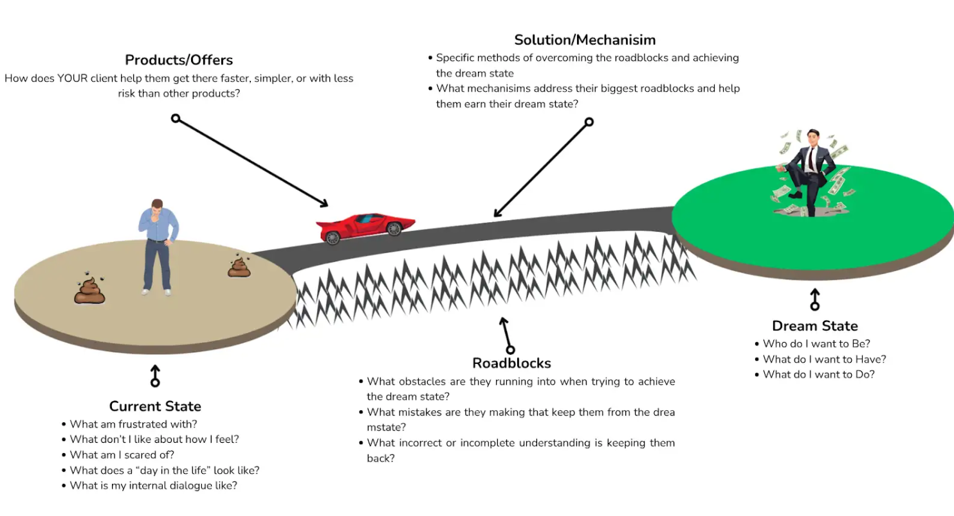
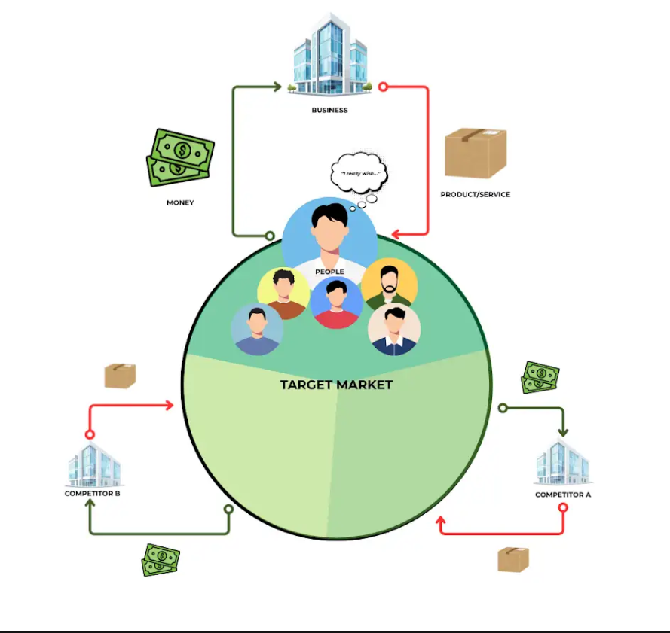

market_research_template
”


You start where the market talks without being asked.

YouTube. You search "starting pilates over 40" and "my pilates journey." You find women filming themselves talking about why they started, what they were afraid of, what changed.

One woman, three minutes into a video with 4,000 views, says: "I kept telling myself I would start taking care of myself on Monday. For two years."

You write that down under Current State.

Facebook groups. You find three pilates and fitness communities. Not the instructor groups. The ones where regular people ask questions and share experiences.

Someone posted: "Is it weird to go to a class alone? I don't know anyone who does this."

Someone else replied: "I almost cancelled my first class three times."

Another: "I thought everyone would be in amazing shape and I would be the only one struggling."

You write all of it down. Current state. Roadblocks. Their words. Their fears.

Google reviews. Not for Linda. For every well-reviewed pilates studio you can find. You are not reading these to judge the businesses. You are reading them to hear the customers.

The five-star reviews are where people describe the transformation. The language they use for their dream state.

"I finally feel like myself again."

"For one hour a day, I am not someone's mom or someone's employee. I am just me."

"I have energy at 5pm for the first time in years."

You are starting to see the pattern. These women are not buying exercise. They are buying a version of themselves back.

Question 1/7
GUT CHECK

You have been collecting phrases for over an hour now. YouTube confessionals. Facebook group posts. Five-star Google reviews.

Based on what you have read so far, what do you think these women are actually buying?

- Expert instruction from qualified trainers
- A version of themselves they lost along the way
- Fitness classes and exercise programming

Answer no:2

_________________________________________________________________________________________________

The three-star reviews are useful too. That is where people describe what almost stopped them. The roadblocks they were aware of.

"The scheduling did not work for my life."

"I felt out of place because everyone seemed to already know each other."

"I could not tell from the website what the classes would actually be like."

These are the barriers between where the target market is and where they want to be. The things that almost kept them from walking through the door.

You keep writing.

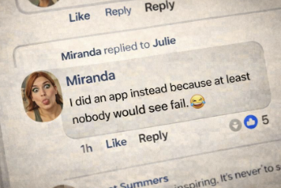

Reddit. Forums. Blog comment sections. Anywhere regular people describe making the decision to try something like this.

You search for how they evaluate their options. How they decide between yoga and pilates, between a studio and a home workout app, between spending the money and staying on the couch.

One thread stands out. A woman wrote: "I did an app instead because at least nobody would see me fail."

That sentence tells you more about this market than any demographic profile ever could.

You write it down under Solutions. This is how they evaluate. Privacy. Judgment. The fear of being seen as someone who does not belong.

Two hours in. Your template is filling up.

You do not have every answer. There are gaps. Things you will need to confirm later with real conversations.

But you have something you did not have this morning. You have the market's voice. Dozens of real phrases from real people describing their current state, their dream state, the roadblocks in between, and how they think about the solutions available to them.

None of it came from your imagination. All of it came from them.

Question 2/7
RESEARCH CHECK

You have been reading reviews, social posts, and YouTube videos for two hours. Your template has dozens of real phrases from real people.

What makes this research more valuable than just guessing what the market wants?

- You have collected a large enough sample that it is now statistically valid for advertising purposes

- You now have enough content to post on Linda's social media without needing to create anything original

- You are writing with their language instead of yours, which means your copy will match how they already think and feel

Answer no: 3

CORRECT ✅

Right. Their words, not yours.

When your copy matches the language they already use in their own heads, it does not feel like marketing.

It feels like someone understands.

______________________________________________________________________



Now you switch gears. You have the market's voice. Time to see what the businesses are saying back to them.

First pass: every pilates and fitness studio within 30 miles of Linda. Websites. Instagram. Google ads if they run them. Offers. Pricing pages.

One question per studio: does their marketing match what the market actually said they care about?

Two hours. You go through all of them.

Most of them look identical.

Class schedules. Instructor credentials. Stock photography of women in activewear looking serene. Professional. All levels welcome. Book your first class today.

You look at your template. The market said they feel burned out. They said they are afraid of being judged. They said they almost did not come. They said they wanted to feel like themselves again.

The competitors are talking about class schedules.

Nobody is speaking to any of it.

Question 3/7
PREDICTION

You just reviewed every local competitor within 30 miles of Linda. Websites, Instagram, ads, offers.

Before you look at the top studios nationally, make a prediction. How many of the top businesses do you think speak directly to the feelings you found in your market research?

- None of them. Talking about classes and schedules will be enough for the people who actually want to attend

- Most of them. Speaking directly to what the target market wants is going to be what helped them grow

Answer no:1
_________________________________________________________________________________

You zoom out.

Second pass: boutique pilates studios in LA, New York, Austin, Chicago, Portland. You are not looking to copy anyone. You are looking for the businesses in this space that are clearly doing better than the rest.

More genuine reviews than the others. More followers. Posts and ads that people are actually engaging with. Running ads for a long time, because nobody keeps paying for ads that lose money.

You cannot fake hundreds of real people choosing you over everyone else. If a business has that, they figured something out about this market.

Your job is to figure out what that something is.



One studio stands out from the rest. A boutique pilates space in Portland, Oregon. 340 Google reviews where the others have 20 or 40. Nearly five stars. An Instagram where people are actually commenting, not just liking. Content that has been running consistently for months.

They don't have the best logo but this is the business where the most real people showed up and stayed.

Their tagline: "Where women come back to themselves."

You look at your template. Under Dream State you wrote: "I finally feel like myself again."

It is almost the same sentence.

You go through the Portland studio's entire online presence.

Their website landing page does not mention class schedules until the third page. The page speaks directly to the woman who feels burned out and has been putting herself last. Their Instagram does not post equipment photos. They post short testimonials from members describing how they felt before and after.

Their ads do not say "all levels welcome." They say "you do not need to be ready. You just need to show up."

Every piece of their marketing maps directly onto the language in your template. Current state. Dream state. Roadblocks. They have done this research. Or they figured it out through years of trial and error.

Either way, it works. They have 340 five-star reviews to prove it.

You study two more top studios. Same pattern.

The ones that are thriving do not lead with information. They lead with identity. They speak to who the customer is, not what the product does.

They match the market's language. The struggling studios match each other.

You can reverse engineer exactly what these top studios figured out about the target market by reading their marketing backwards. Every headline, every ad, every email sequence is a clue about what the market responds to.

You add the clues to your template. More language. More insight. Gaps filling in.



You sit back and look at your template next to your competitor notes.

The mismatch is brutal.

The market says: "I feel burned out. I have been putting myself last for years. I am afraid I do not belong in a place like this. I want to feel like myself again."

Every local competitor says: "Professional Pilates for All Levels. Book your first class today. Check our schedule."

The top studios nationally say: "You do not need to be ready. You just need to show up. Where women come back to themselves."

The local competitors are not wrong. They are irrelevant. They are answering questions nobody asked. They are describing features when the market is searching for someone who understands how they feel.

The gap is not that Linda needs better marketing. The gap is that nobody in her entire local market is even speaking to these women.

And now you know exactly what they want to hear. Because they already told you.

Question 4/7
YOUR STRATEGY CALL

You have the market's language in your template. You have the local competitor audit. You have the top player reverse engineering.

What is the real opportunity here?

- Linda should lower her prices to undercut the local competition since they all offer the same thing

- The research phase is complete and Linda should start posting content immediately based on what worked for the Portland studio

- Linda can be the first local studio to speak directly to what the market actually feels, using the gap between what they want and what every local competitor is saying

- Pick the most successful studio's exact marketing and recreate it word for word for Linda's business

Answer no:3

CORRECT ✅
Right. The opportunity is the mismatch.

The market is describing fears, identity, and transformation.

Every local competitor is describing schedules and credentials.

Linda can be the first to bridge that gap.
__________________________________________________________________



Two taglines open on your screen.

Linda's: "Professional Pilates for All Levels."

And the studio in Portland, Oregon, two states away and thriving: "Where women come back to themselves."

You look at them side by side for a long moment.

You call Linda.

"I have been doing some research. I want to show you something."

"Good or bad?"

"Both. Mostly good."

A pause. "Come over," she says.



You show Linda the two taglines side by side.

She reads them. Reads them again.

She points at her own. "That sounds like a dentist."

You do not disagree.

"The good news," you tell her, "is that none of your local competitors are saying anything close to what the top studios are doing. That whole position. Nobody local has claimed it."

She looks at you. "So we could be first."

"If we get this right. Yes."

She is quiet for a moment.

"Okay. So we know nobody local is saying anything real. And we know the studios that are winning are speaking to something emotional. Something that sounds a lot like what Sarah described."

She pauses.

"But we still don't know if the women in this city, the ones who have never heard of me, actually feel that way."

She looks at you. "So we have a strong hypothesis. But it's still a hypothesis."

You nod.

"So let's find out."

💬 COMMUNITY CHALLENGE 💬

Before you continue.

In the story you just completed a full competitor analysis and found a gap nobody local has claimed. Can you do it IRL?

"What is one type of business where you think the whole industry sounds the same and nobody is saying anything real?"

Go post your answer in the Newb Chat.

PS - The students who do these exercises tend to perform best when there is real money on the line.

Question 5/7
ACT 1 REVIEW

Linda has been posting on Instagram for two years with almost no engagement. She asks you if she should switch to TikTok.

What should you figure out before recommending any platform?

- Which platform has the lowest cost per click for fitness ads in her area
- What type of content is trending on TikTok right now in the fitness space
- Who she is actually trying to reach and what that person responds to

Answer: 3

CORRECT ✅
Right.

The platform is irrelevant until you know who you are talking to and what they care about.

Every tactic decision comes after that.

Question 6/7
ACT 1 REVIEW

You read 340 Google reviews for a successful studio in Portland. Several customers write things like "I almost didn't come the first time" and "I didn't think someone like me did this."

Why is this useful?

- It gives you the actual emotional language your target market uses to describe their experience, which becomes the raw material for your marketing

- It proves Portland's marketing is better than Linda's, so you should copy their exact strategy

- It tells you the studio has a welcoming environment, which you should mention in Linda's marketing

Answer no:1

CORRECT ✅

Those phrases are psychographic gold.

When real customers describe their fears and transformations in their own words, that language becomes the foundation of everything you write.

You are not guessing what to say. The market already told you what works.

Question 7/7
ACT 1 REVIEW

Every local pilates studio in Linda's area markets the same way: class schedules, instructor credentials, stock photos, "all levels welcome." Meanwhile, the top studios nationally speak to emotions and identity.

What does this create for Linda?

- A positioning gap where she can be the first local studio to speak to what her market actually feels

- A sign that this market does not respond to emotional marketing because no one local is doing it

- A pricing opportunity because she can charge less and undercut the generic competition

Answer no:1

CORRECT ✅
The national studios prove it works.

Nobody local has claimed it. Linda can be first.

But you still need to confirm the hypothesis before you build on it.

🏆 ACT ONE COMPLETE 🏆

You can now sit across from any business owner, look at their marketing, and name the gap between what they are saying and what the market needs to hear. You can pull real language from real people and use it to see what an entire industry is missing.

That is a skill most people in this space never develop.

What you do not know is whether your hypothesis about these women is actually true for the women in Linda's city. There is only one way to find out.

SKILLS UNLOCKED:

☑️ Define target buyer

☑️ Research market voice (reviews, social, YouTube)

☑️ Fill market research template with real language

☑️ Audit local competitors

☑️ Study top players and reverse engineer their positioning

COMING NEXT 👇

ACT 2: CIA Insider Research
Getting them to share what they will never say in a review

market_research_template
Market Research
Template

Fill every section with real language from real people.
Not your guesses. Their words.
Where to find them: YouTube videos, Facebook groups, Google reviews, Reddit, forums, social
media comments, competitor websites, top player marketing.

1. Current State
2. Dream State
3. Roadblocks
4. Solutions
5. Products / Businesses

1. Current State
How do they describe their life right now? What words do they use for their frustrations, pains, and dissatisfactions?
What do they complain about when they think nobody important is listening?
•
•
•
•

2. Dream State
What do they wish their life looked like? How do they describe the version of themselves they want to become?
How do they hope others will perceive them once they have overcome this problem?
•
•
•
•
3. Roadblocks
What do they believe is stopping them? What fears or doubts do they mention when they talk about making a
change? What excuses do they give for not taking action?
•
•
•
•
4. Solutions
How do they evaluate their options? What have they already tried that did not work? What do they think about
doing it themselves versus paying for help? What would make them pick one path over another?
•
•
•
•
5. Products / Businesses
How do they decide between specific providers? What makes them trust or distrust a business? What do they look
for before they buy? What has made them walk away in the past?
•
•
•
•

The CIA Method


A few days after the market walk. You sit down to test what you have.

You pull up your market research template. All five categories filled. Current State. Dream State. Roadblocks. Solutions. Products. Dozens of real phrases from real people.

You open a blank doc. Twenty minutes. Just see what the research produces when you try to use it.



🛑 THE WALL 🛑
Your template is full. The phrases are real. The framework is sound. And the copy is still dead.

You know how these women describe their situation. You do not know what the actual decision moment feels like from the inside.

What crosses her mind when she first sees the hook. What she is telling herself when she almost books and then closes the tab. What finally tips her.

None of that is in any review. Sure you could guess, but the answer lives inside people who have been through it and you have not talked to any of them yet.

Question 1/7
THE GAP

You sketched out a rough landing page using real language from your market research template. It covers the framework. It is not obviously wrong. But reading it back, something is missing.

What specifically do you still not know?

- The copy needs stronger formulas and structure before it would actually persuade anyone to act

- You know how these women think about their situation but not what the actual decision moment feels like from the inside

- The draft needs more detail about Linda's studio, her offer structure, and her credentials

- You have not seen enough competitor landing pages to know if this is differentiated enough

Answer no: 2

CORRECT ✅

Right. Reviews are post-decision language.

You need pre-decision language.

That only comes from talking to people who have lived it. The next step is finding the right people to talk to.

______________________________________________________________________________

Below is our Professor Andrew’s Comment:

“THE CIA METHOD

All right, so we've spent a lot of time talking about how you can go and you can find out information about your target market via research.

We talked about a whole different series of ways you can go online, where to check and see what they say, so you can get a deeper understanding of how they think, so that you can tailor everything you say to catch their attention and get them to buy.

And that's been great.

And there's a lot of that basic, open source, regular intelligence you can find just by going and looking around.

But, It's only gonna get you so far.

The research you do online, the things you see, it's only gonna give you part of the picture.

Now it's better than having nothing.

It's better than just completely guessing, but it's still not quite enough to have a huge edge that's gonna allow you to get these people to want to buy from you better than anybody else.

You need something else.

You need a little bit more of an edge.

And I'm going to teach you, or rather, I'm gonna help you steal something used by the United States government, the United States State Department, and a few adjacent agencies, a cheat code that is gonna allow you to get inside information from these people.

So let me kind of break down this analogy so you understand this before I lay out the entire method.

So, when governments interact with each other, the U.S. Government, when it interacts with its foreign foreign countries, allies, partners, enemies, it operates on like an official level, diplomats will sit down, we'll have dinner, and they'll talk about stuff.

There'll be information that's sort of publicly available about the country, and the government will use this, the State Department, the president, or whatever.

We use this information to decide whether or not to go to war, how to negotiate, you know, this trade deal or what have you.

They use all this publicly accessible information, just kind of like the way you went and found a bunch of public information about your target market.

The government does the same thing with foreign countries that they interact with.

But, the U.S. Government is famous for not just sticking with, like, the basic public official channels.

The United States government is famous for going in and getting secret inside information behind the back of these other governments so that when they sit down to do their negotiation or decide to attack the country or have you, they have an unfair advantage.

They know where all the weapons are.

They know the internal procedure, they know where this person's gonna be, and they're able to use that unique inside secret information to better run the, you know, their stretch theoretically, you know?

And they do that by a little agency you might have heard of it.

It's called the CIA.

Like I mentioned before, I'm the only one who will teach you this outside of maybe a place called Langley.

But I'm gonna teach you how to do the exact same thing that the CIA does when they go onto a foreign country and recruit a foreign person that works in the government and convince them to be an agent or be a spy and tell them the secret information.

I'm going to teach you how to do the exact same thing, but with members of your target market.

I'm gonna teach you how to do it with, what in the world is that?

I'm gonna teach you how to do it with, there we go.

I'm gonna teach you how to do it with people from your target market to get people who you're trying to sell to to give you the inside scoop, the information, the stuff that you can't find here, and you should do this.

Like, this is very important.

You got to get the basic stuff, figure it out.

I mean, the CIA does the exact same thing. Open source intelligence.

But you also need to combine it with human intelligence, human, and you need to do that by going out and finding people that are inside of the target market, and getting them to share some very specific pieces of information and help you, so then you can tailor all the marketing, all the work that you do to get their attention directly to them.

You will have an inside scoop, the secrets, just like the CIA does this in the government, you'll do this with your target market.

Now, Let's talk before we get into like exactly what we need to do with them.

Let's talk about how you find these people to work with.

So, The 1st way that you're gonna do this is, especially if your clients are comfortable with this, anybody who's already purchased from the business, like anybody, any person who's in the target market, who found this company that you're working with or that you own, and has decided to buy, they were and are members on that target market.

And you can speak with them.

So you can get your clients, the businesses you work with, to introduce you to some of their customers.

And you can talk with them, and you can interview them and get this information.

That's one way.

Not every business is going to be extremely excited to let you talk to their customers.

They, you know, that might come later as you develop a little more trust with them.

Um, so, so you do that when you can.

But also a lot of times you'll just find people that you know in your current network, your friends, your family members, your uncle, your aunt, that person you went to school with or what have you.

Most of the time, whenever you work with a business and you partner with a business, their target market, you probably have somebody you know in your personal network or family or friend group, then actually either is directly in the target market or is fairly adjacent to the target market.

They might be like over here.

It might not be super in the target market, but they're close enough that they can give you a better insight into how these people think than you can by yourself.

So those are kind of the 2 main ways.

You can do a little bit of it online interacting with other people online, but basically, Your client is either going to introduce you to people in the target market, their previous customers, or you are going to go out and use people that you know, friends of yours and talk with them and get them to give you this inside information.

So those are the 2 main methods.

You'll find that a lot of times it'll be on you to source your own insiders.

It's on the, you know, the CIA operative.

It's on him to, like, make contact with somebody behind it. You know, in the country.

So he can he can find somebody and sources on him a lot of times.

It's going to be on you a lot of times as well.

But we can talk more about that in some advanced things, and there's a lot of guys in the chat that can help you out with this that particular question.

Once you found somebody and you sat down with them, you're gonna do a couple of things.

Like when you sit down to interview them, you need to prepare beforehand.

You need to know what you're looking for and how to get it.

We talk about the different methods or tactics you're gonna use.

But real quick, let's talk about how you plan this conversation.

So when you sit down with these people, you you want them to be open with you and you want them to share this information.

You gonna want to frame the conversation around them helping you, help the business owner.

Hey, I'm running this project. Have some questions.

It'd be really helpful for me if we could we could cover this.

I just, you know, I would love to pick your brain about this.

Or, hey, um, let's say it's one of the customers of your business.

Hey, I know you really like Linda.

She's got a great thing.

This is a great class.

We're working to get more people in the door like you to experience how beautiful this is.

I'd love to pick your brains.

She said you were one of her favorite students, and you probably understand this whole place better than even she does and love to talk.

You usually go and we're gonna want to pump these people up and make them feel important for participating.

If they're your friends and family, you should consider giving them gifts.

I can either confirm nor deny that I've had my wife cook, like, baked cookies for CIA insiders that I have used for marketing projects.

Can either confirm nor deny.

I have bribed with cookies.

But you want to sit down with these people in, like, 15 minutes, you want to have a quick conversation with them.

Before you go in, you want to think about the kind of information these people might have that you would need to know.

Like, again, you're gonna go through your market research, you're gonna be looking at, you know, their roadblocks and problems.

There's going to be certain gaps or places where you're not exactly sure what's going on and I can talk about some of those here in a second, but you're going to identify, if you can, any questions that you'd like to have answered. About this.

Any intelligence gaps that exist before you go in?

You don't wanna think about that.

But basically, every CIA interview, every asset that you interview, every target market insider that you talk to to get your feedback, to help you market better.

You're gonna kind of go and look for 3 main categories of information.

The 1st one is, you're gonna map their journey.

When you go through and do your online research, I keep switching back and forth to help show you this.

When you go and look at this, when you look online, the reviews, and the testimonials, and the videos, and the competitors, you'll see what, you'll see what the target market says about their journey, or just, what they say about different little snippets, piece, here, piece, there, piece, here, of their experience.

You'll get their opinions, but you won't really get to see what they did.

Their actual actions they took as they were finding the business and deciding to buy.

You won't really see this series of actions.

And that's something you usually have to find by talking with people directly.

You can, sometimes your clients will know a little bit of this, but generally speaking, you need to talk to the actual person.

Just like an investigator who's trying to, like, find clues and figure out who did it.

You want to establish a sequence, a timeline of events.

Whenever I sit down with the target market insider, I like to ask them to tell me the story of how they found out about this business and how they, why they decided to buy. Or what their life was like when they were dealing with the problem and how they went about trying to solve it.

And I just let them go into story mode.

And you sit there and with all these interviews, you want to be really attentive.

I like to take notes.

I like to ask them follow-up questions.

We'll get into some of the main follow-up questions you're going to ask about this, but you want to get a series of events.

You want to know what was happening before?

You want to know if they did any research, how they search, what keywords they used in Google or AI to try and solve this problem, where they went, here, how they did this, what they thought about that, what options they compared to?

You're gonna want to get all the things they did, between them like having this problem, and then buying the product and solving the problem.

You want to get the full sequence of events.

That's the 1st thing.

And that'll give you a lot of clues that we'll use later when we're planning the exact marketing strategies.

Do we use this platform, that platform?

A lot of that will be informed and enhanced by us understanding what's actually going on in the journey.

And we're going to find some things that we couldn't find during the market research where we're just looking at stuff online.

People talking online, sitting down face to face with somebody, you're going to discover a whole lot of things about how they evaluated their choices, where they looked, et cetera.

So that's the 1st thing you're going to do.

The other thing you're going to look for as you go through is you're going to want to extract more of their language.

So, you're gonna have the sequence of events.

And if you look at your old research online, you'll see things that they said about those things.

But one of the cool things about the CIA insider is when you talk to these people, A, you're just gonna get some cool extra information about, you know, the Roblox and desires and the phrases they used to describe that.

You'll get that, obviously, right?

You slap that in your document.

Well, one of the cool things you'll be able to do is you'll be able to ask them, like, internally what was going on here.

What were you thinking?

When you were deciding this?

What were you worried about?

Or were you afraid of?

Things they never said out loud, things they never even realized they were thinking, things they sure as hell never put inside of a review somewhere.

You're gonna go, and you're gonna ask them questions about this, and this is where you have to be empathetic.

You have to care about this person.

You have to be interested in them, to be genuine.

But if you ask them these questions, you can get their internal dialogue, the way that they actually think about all of this, the little objections they never told anybody, but just figured out by themselves and how they figured it out.

You're gonna find a whole wealth of information, and this gives you an edge, just like, you know, the State Department needs insider secret information when they're planning a war or, you know, doing advanced negotiations with somebody.

This will allow you to have inside information when you go and actually talk to these people.

You be able to catch them at the right moment, and you'll be able to say, the right thing to get them to decide to pay you money.

Anyways, you're gonna go through this, and you're gonna kind of go back and forth between finding the points and asking them about it.

Like, it's not going to be terribly linear, but you see stay engaged, stay interested.

When they start opening up to you and telling you some of these things, you gotta kind of reward them verbally.

You gotta tell them, wow, thank you so much.

That's really cool.

I've even thought about that.

Um, you know, I was thinking this other thing.

You got to make them feel important and kind of thank them for telling you this and tell you, you got to tell them how important it is.

Again, they're going to be doing this probably for free or cookies.

So you're going to want to do whatever you can to make them feel important and reward them with that feeling of importance and appreciation.

So just be a good person and tell them thank you.

You know, I mean, this is the CIA might torture people, but most of what the CIA does is they bribe and make people feel special.

That's basically how they get inside information, you know.

Don't tell anybody.

I mean, they do some torture too.

I mean, Guantanamo Bay was real.

But a lot of what it's done is just finding people and then making them feel special and getting the inside information.

You can do the exact same thing, which is, like, overall, a pretty nice thing to do to somebody.

The other big thing that you're gonna do, the sort of 3rd category, is you're gonna use these conversations to battle test your marketing ideas.

And you probably won't do this the 1st time you sit down with them.

You might have them look at your client's website or what have you.

But one of the coolest things you can do with this is you can sit down with these people once you've got the information from them.

And then you can show them, hey, I've got this idea for an ad.

Here's a little mockup for an ad.

And here's, like, my competitor's ad.

Which of the two do you like and why?

And you can battle test the stuff really, really quickly, and we're gonna have more or lessons on this as we go through the course.

But, uh, you can battle test very quickly and figure out how they would respond to something before you go and launch it before you waste money on ads, you can get some pretty quick feedback and iterate with them, and have them compare yours against the competitors or against the top player, against other people.

And you can get their feedback and they can tell you why they like this or why they don't like that.

You can take that and use that.
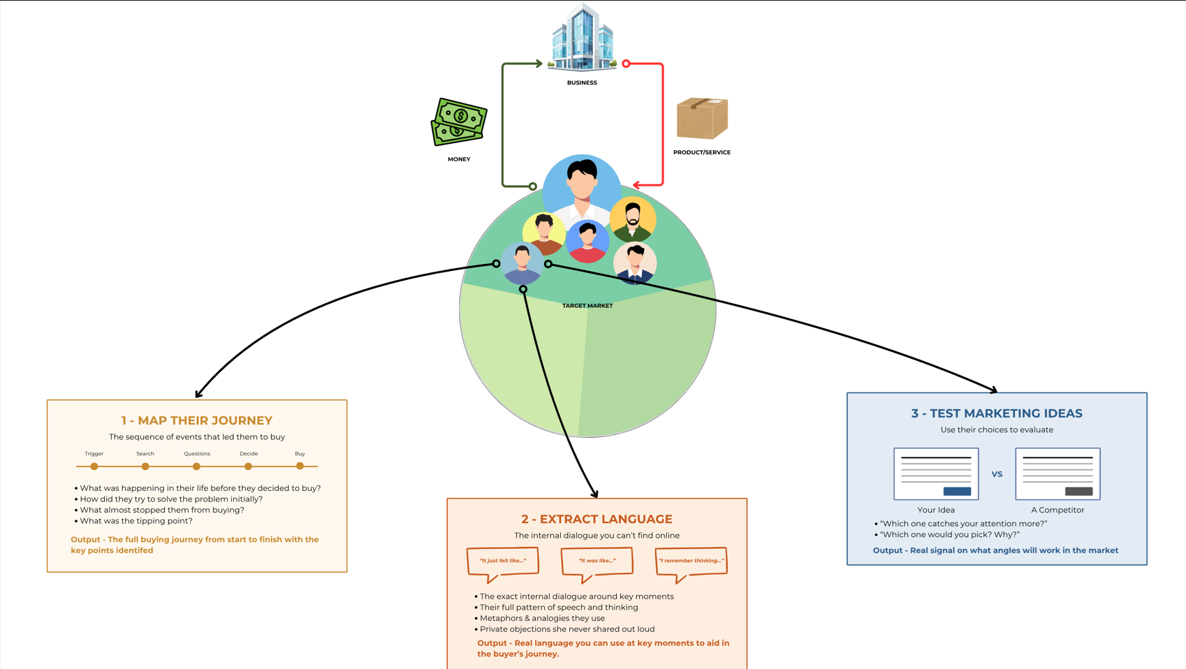

It's one of the best ways to kind of like get this guy to tell you it's going to work before you launch it.

And again, it doesn't get guaranteed that every time you launch it, you're going to have everything perfectly right.

But this insider information, just like having insider information from the CIA doesn't guarantee you they're going to win the war, but it sure makes it a hell of a lot easier.

Same thing happens here.

Getting this inside information beyond just what you got from the market research, taking time to go find people, multiple people who are inside your target market, finding out about their journey, figuring out exactly how they think about these problems, using their feedback to determine which path to go, which strategy, use, which tactic you should launch, will give you a huge advantage over everybody else, help you tailor your marketing, to match their internal thoughts and procedures, and end up cashing in.

It's gonna give you a huge advantage over any of their business who, A, never learned this tactic.

B, he's too lazy to talk to people and C, it's probably just spewing random marketing anyways.

You become absolutely lethal with this method.

So, as we continue through this, you're gonna learn more about this method, the CI method has sort of nuances and some more advanced things.

You going to see a play outside the story.

Um, you'll have plenty of opportunities to practice this, and, and it's a great way to get inside information and give you a huge leg up so that you can catch them where they are and convince them to buy your product.
Cia_precall_checklist_1”

Question 2/7
KNOWLEDGE CHECK

You produced a draft that covers the framework correctly but feels inert.

What does the CIA Method specifically solve that more research cannot?

- It helps the business owner feel involved in the process so they trust your recommendations more
- It gives you a structured process for talking to strangers so the interviews feel professional rather than awkward

- It maps the real buyer's journey from the inside, extracts precise language, and lets you test your marketing against competitors using the same people who gave you the intelligence

- It generates testimonials and social proof you can use directly in the finished copy

Answer no: 3

CORRECT ✅

Right.

The CIA Method does three things at once.

It maps how the decision actually happens from the inside.

It gives you the precise language your template was missing.

And it lets you test your work against real alternatives using the same people, so you know what wins before you launch.
___________________________________________________________________



You message Linda and let her know what you have in mind.

She offers to connect you with people from her member list. She mentions a few names.

You want to keep this tight. Two conversations, each serving a specific purpose.

You think through what you actually need.

One person who made the decision and completed the journey. She can tell you what the decision actually looked like from the inside and what the right marketing feels like to someone who already converted.

One person who fits the profile but has never walked through the door. She can tell you what is still in the way and what the marketing looks like to someone who has not decided yet.

Those are two different problems and you need both sides.



You tell Linda you want one current member. Someone who almost did not come in.

Linda does not hesitate. "Megan."

Fifty-three. Dental hygienist. Youngest just left for college six months ago. Comes four times a week now. Has referred two friends. Linda says she almost quit in week two but stayed.

That is the journey you need to understand

Question 3/7
CHOOSING THE NEXT INSIDER

You have two insider slots. Megan is a current member Linda suggested. She almost quit in week two but stayed. You are thinking about who to source yourself for the second slot.

What should guide that decision?

- Think about what question you still cannot answer after the first call, and find someone who can answer it

- The second insider should be someone who tried the same business and had a negative experience

- Always pair a buyer with a non-buyer so you have both sides of the decision represented

- Always match your second insider to whoever feels easiest to find in your personal network

Answer no: 1

CORRECT ✅

Right. The pairing is not a formula.

It is a decision based on what you still need to know. Megan will tell you what completed the journey.

The remaining gap is what keeps someone from starting it.

That is why Carol, a non-buyer who fits the psychographic, is the right second choice here.

Question 4/7
SOURCING THE SECOND INSIDER

Imagine your client is happy to help but only comfortable asking one person.

She does not want to put her customers in an awkward position. You need a second insider.

What do you do?

- Post in a Facebook group related to the niche and ask for volunteers to answer a few questions

- Explain that one insider is not enough and push the client harder to provide more contacts
- Look in your own network for someone who fits the psychographic, even if they have never heard of this client

- Skip the second interview and work from the one conversation you have

Answer no: 3
CORRECT ✅

Right. Clients will often be protective of their customer relationships.

Sourcing from your own network around the psychographic is a standard part of the process, not a workaround.

The insider does not need to know your client.



You think about the second conversation. You need someone who fits the psychographic but has never heard of Linda. Someone who will tell you the truth without any loyalty to the client in the way.

You think about your aunt Carol. Late 30s. No kids. Works in event planning. Client-facing, deadline-driven, always on. Pours everything into work and keeps telling herself she will start taking care of herself once things slow down. Things never slow down.

She signed up for a yoga class in January. Pulled something in week three. Took two weeks off to rest it. The habit just never restarted.

She fits the psychographic. She has no loyalty to your client.

You text her: "Hey, random question. Can I grab thirty minutes with you this week over a video call? I am working on a marketing project and I think your perspective would be really valuable."

She replies in four minutes. "Sure, Thursday works."


Insiders are lined up. You open a notebook to plan the interviews.

Each interview has two phases. Phase one: map the buyer's journey and extract the precise language. Phase two: show them real marketing and watch them choose.

You need to plan both before the first call.

Fifteen minutes with each person before it gets awkward. You cannot afford to waste time on the wrong questions or fumble the funnel comparison.

The wrong questions get you the polite version. The right questions get you the truth.

You need to know exactly what you are doing in each phase before the call starts.

Question 5/7
PHASE 1: THE BUYER'S JOURNEY

You want to understand the sequence of events that led Megan to walk into Linda's studio for the first time and what was happening inside her head along the way.

Which question opens that up?

- What was going on in your life right before you decided to try this, and what were you hoping would change

- How long did you think about joining before you actually booked

- How did you first hear about the studio and what made you look into it

- What did you expect it to be like before you came in for the first time

Answer no:1
CORRECT ✅

Right.

The question before the question. Life context at entry.

What she was hoping would change.

You are about to hear Megan answer this exact question and the answer will rewrite your template.

Question 6/7
PHASE 1: THE NON-BUYER

Carol signed up for yoga in January and stopped by February. You want to understand what is actually keeping her from trying something new.

Which question reveals it?

- How does your schedule look right now and what would need to free up for you to start?

- If you absolutely had to try one fitness thing in the next 30 days, what would it be?

- What has stopped you from going ahead and trying something again?

- What would a studio need to offer for someone like you to feel like it was worth trying?

Answer no: 3
CORRECT ✅

Right on the money G.

Question 7/7
PHASE 2: THE FUNNEL COMPARISON

You are about to show Megan two studio websites and ask her to react.

What is the most useful way to frame this?

- Which of these do you think would appeal to more women in your situation?"

- "Which of these looks more professional to you?"

- "What would you change about each of these to make them better?"

- "If you were scrolling and saw both of these, which one would make you stop and click, and what about it pulled you in?"

Answer no:4

CORRECT ✅

You are not asking for a critique or a design opinion.

You are asking them to react as a customer.

Which one would actually stop them mid-scroll?

That reveals preference in a way that a simple review never does.

You write down the plan.

Phase one: start with the life context. What was going on before the decision. Then follow the sequence of events step by step. At each step, probe for the internal experience. What were you thinking? What were you feeling? What were you telling yourself?

Phase two: share your screen. Show Linda's current site next to the Portland studio. Ask which they would click and why. Then show your rough draft alongside both. Get a gut reaction.

You are ready.

CIA INTERVIEW CHECKLIST
CIA INTERVIEW CHECKLIST
Before. During. After.
BEFORE THE CALL
☐ Market research template filled out
☐ Client's current marketing ready to screen share
☐ Top player marketing ready to screen share
☐ Notebook open for their exact words
PHASE 1: THEIR JOURNEY
☐ Get them to go back in time to before the decision
☐ Map the sequence of events step by step
☐ At each key step ask: what were you thinking? what were you feeling?
☐ Write down their exact words, not your summary
☐ Reward them when they share something personal
PHASE 2: SHOW AND COMPARE
☐ Show client's marketing next to the top player's
☐ Ask: which would you click and why?
☐ Show your rough draft alongside both
☐ Preempt the niceness. Tell them to be harsh.
☐ Reward critical feedback. Do not react emotionally.
AFTER THE CALL
☐ I know what their life looked like before the decision
☐ I know the sequence of events that led to it
☐ I know what almost stopped them
☐ I have their exact words for their fears and desires
☐ I know which marketing they preferred and why
☐ I know what felt off about the weaker options
☐ I updated my market research template

Their feedback is directional, not literal. Use it to get closer.

Insider Secrets
Megan lights up.

She starts talking about how much she loves the studio. The community.

How Linda remembers everyone's name. How she finally has something that is hers. She is glowing.

This is wonderful to hear… and it's also completely useless to you right now.

She is telling you about where she is NOW

You need to know where she was THEN.

🛑 THE WALL 🛑

This is the trap. Happy customers talk about the present.

They tell you how great things are now.

They skip the part that matters to you: what it felt like before they walked through the door.

That is where your marketing needs to speak to. Not the after. The before.

If you let her keep going, you will leave this call with a glowing testimonial and nothing you can actually write from..

Question 1/4
PROBING THE BEFORE STATE

Megan is describing how she feels now. You want to understand what her life looked like before she joined.

Which question gets there?

- Did you look at other studios before you decided on this one?

- How often were you exercising before you started coming here?

- What results have you noticed since you started coming regularly?

- What was going on in your life right before you found Linda's studio?

Answer no:4
CORRECT ✅

This opens the door to the emotional before state, which is where the marketing needs to speak to.

Her life context at entry is more valuable than her exercise history

____________________________________________________________________



She pauses. Goes quiet for a moment. Then it comes.

Her youngest left for college six months before she found Linda's studio. Twenty-five years organizing herself around other people's schedules and then one morning there was just nothing. She was not looking for a studio. She heard about Linda from a colleague. She went once to fill a Tuesday.

She almost quit after week two. Not embarrassment exactly. More like invisibility. She kept showing up and feeling like nobody would notice if she stopped. Then Linda sent a personal text after a Thursday class: "You did something hard this week. I'm proud of you."

You ask her what she was really hoping for when she walked in. She pauses.

"I just wanted someone to treat me like I wasn't already broken."

You flip open your template.

Under Current State, you cross out "burned out" and write: "invisible after years of being the one who held everything together."

Under Roadblocks: "kept showing up and feeling like nobody would notice if she stopped."

Under Dream State: "someone to treat me like I was not already broken."

Deeper. More specific. The desk research phrases were directionally right. Megan's words are precise. One question got you here. That question came from the interview plan. The plan came from knowing what your desk research could not tell you.



Next you tell Megan you want to show her a couple of things.

You share your screen. Linda's current website on one side. The Portland studio's website on the other.

"If you were scrolling and saw both of these, which one would make you stop?"

Megan looks at Linda's site. Shrugs slightly. "It looks fine. Professional. I probably would have scrolled past it, honestly. It does not really say anything to me."

She reads the Portland homepage longer. "That one feels like it was written by someone who knows what it is like. The come back to yourself thing. That is what it felt like."

Then you show her your rough draft.

She reads it. "This is somewhere in between. Some of it sounds right. But I can tell it was not written by someone who has been through it."

She points to a line about feeling burned out. "That is a little too... I do not know. General? Like it could be about anything."

"Burned out" was the desk research phrase. It is too vague. Megan just told you it was invisibility, not exhaustion. The draft used the right category but the wrong word.

Question 2/4
THE GAP

Linda's Instagram says "Professional Pilates for All Levels." Megan said "I just wanted someone to treat me like I was not already broken."

What is the gap between those two statements?

- Linda's marketing describes the product and the service, not the transformation or the feeling

- Megan's experience is unique to her personal relationship with Linda and probably does not transfer to cold audiences

- Linda should use Megan's exact quote as a testimonial somewhere on the landing page

- Linda needs to lead with her credentials and professionalism more prominently in her marketing

Answer no:1
CORRECT ✅

Right.
The product is fine.
The marketing does not speak to what people are actually looking for.
That gap between the product and the message is what you are going to close in Act 3.

______________________________________________________________________



Next you speak with your other Target Market Insider

Carol joins the video call. She is easy to talk to, slightly rushed. She is between client deadlines.

You ease in. Ask how things are going. Then you ask what happened with the yoga class she mentioned back in January.

"Oh, I pulled something and then just never got back into it. Work got crazy."

She says it like it is already resolved.

But That isn't the real answer.

🛑 THE WALL 🛑

Carol is not being evasive. She genuinely believes this is the full explanation.

The physical interruption became a convenient exit and she has not examined what was underneath it. You know the pulled-muscle story is real.

You also know it is not the whole story.

Question 3/4
GETTING PAST THE POLITE ANSWER

Carol says she pulled something and work got crazy. You think there is more underneath it.

How do you get to it without putting her on the defensive?

- Mention that lots of people stop and restart and it is completely normal to take a break

- Ask: "When you thought about going back after your shoulder healed, what actually came up?"

- Ask about her schedule directly: "What does a typical week look like for you right now?"

- Ask how she has been feeling generally and whether staying active is still something she wants

Answer no:2
CORRECT ✅

Right. Accept the surface answer.

Then ask what happened next.

Carol is about to tell you something she has never said out loud before.
____________________________________________________________________________________



She talks about how she has started things before and then an interruption happens. A client emergency, a bad week, one missed session. And once she misses a few, she cannot seem to rebuild the momentum.

She does not trust herself to be consistent. It is not about the yoga. It is not about the shoulder. It is about the track record she has built against herself. Every time she quits something, the story she tells herself gets a little more fixed.

You add to your template. Under Roadblocks: "what if I fall off again, like I always do."

You tell Carol you want to show her a couple of things. You share your screen.

"I am working on a marketing project and your honest reaction would be really helpful."

Carol barely scans Linda's site. "Looks like a gym website. I would not click on this. It does not really tell me anything I would care about."

She reads the Portland page more carefully. Pauses on "you do not need to be ready. You just need to show up."

"Okay, that one is different. That actually made me feel something. Like whoever wrote it knows what it is like to almost not go."



You show her your rough draft. She reads it. Thinks.

"It is better than the first one. But it still kind of feels like it is about the studio. Like it is trying to convince me to try pilates. But that is not really what stopped me."

You write that down. "It still kind of feels like it is about the studio."

Copy that talks about the product using emotional language is not the same as copy that talks about the person. The Portland studio crossed that line. Your draft has not.



Pilates Studio. You and Linda. Notes spread out. Two interviews. More truth than expected.

You walk her through everything. Not just the emotional language. The complete picture.

Megan's journey from the inside: how she found the studio, what almost stopped her, what made her stay.

Carol's journey from the outside: the polite excuse, the real barrier underneath, the track record she has built against herself.

And what both of them said when you showed them the marketing.

You tell Linda what happened when you showed them the websites.

Carol barely looked at Linda's. She spent thirty seconds on the Portland page. Megan said Linda's looked "fine" and that she would have scrolled past it.

Carol's diagnosis of your rough draft: "It still kind of feels like it is about the studio."

Linda is quiet.

In Act 1 you found the mismatch. Nobody local was speaking to these women. That was true.

But even speaking to them is not enough. Megan and Carol both confirmed a layer underneath the messaging gap.

The real pain is not fitness. For Megan it was invisibility. Being unseen after years of being the one who held everything together. For Carol it is the track record she has built against herself. Every time she has started something and stopped, the story she tells herself gets a little more fixed.

The real hesitation is not "will this work." It is "will I."

That is a different objection entirely. And it is not in Linda's marketing at all.

The real competition is not the studio down the street.

It is the part of Carol that has already decided how this story ends before it starts. The part of Megan that almost let invisibility win.

The thing that kept Megan (Linda noticing, Linda texting, Linda remembering) is the exact answer to what Carol needs. And it is completely absent from Linda's marketing.

The thing that makes people stay is the thing nobody outside the room ever sees.



Linda is quiet for a long moment. She picks up her coffee. Sets it down again without drinking. You have seen her do that before.

"There is something I have not told you."

She reaches into a drawer behind the counter and pulls out a folded letter. Sets it on the table between you. Does not open it.

"The landlord sent this three weeks ago. If membership does not show meaningful growth in 90 days, the lease is not being renewed."

You look at the letter. Then at her.

"I was not going to tell you. I did not want it to feel like pressure. I did not want you to rush anything or feel like this was on you."

She looks around the studio. The reformers she bought secondhand. The wall she painted herself. The corner where Megan cried and then apologized for it.

"This is the only thing I have ever built that was mine."

You look at your notes. You know who these women are. You know what they feel. You know what they respond to and what they scroll past.

Now you HAVE to build something that actually works.

Question 4/4
THE REAL BARRIER

You just walked Linda through what Megan and Carol told you. Based on those two conversations, what is the real thing stopping potential members from walking through her door?

- They feel the pull toward change but do not believe they are the kind of person who will actually follow through this time

- They have heard mixed things about pilates and need more social proof before they would consider trying it

- They do not know enough about Linda's qualifications and studio to feel confident choosing her over competitors

- They are not aware that pilates exists as an option for someone in their situation

Answer no:1
CORRECT ✅

Not "will this work." "Will I." That is a different objection than most marketers ever think to address.

And it is exactly what your copy has to dissolve.

__________________________________________________________________

COMMUNITY CHALLENGE 💬

You just watched two real people explain what pushed them toward a decision and what held them back.

"Think about the last time you bought something significant. What pushed you over the edge?"

Go post your answer in the Newb Chat.

PS - The students who do these exercises tend to perform best when there is real money on the line.

🏆ACT 2 COMPLETE 🏆

You can now extract the precise emotional language that desk research cannot reach. You can map a buyer's journey from the inside, get past the polite answers, and watch real people choose between real marketing in real time.

You know the difference between what people say publicly and what they feel privately. That is the difference between copy that sounds right and copy that actually converts.

The hypothesis is confirmed. The certainty gap is real. The clock is running. 90 days.

What you do not know yet is how to turn all this ammunition into a weapon.

SKILLS UNLOCKED:

☑️ Source insiders (buyer + non-buyer)

☑️ Map Megan's buyer journey from the inside

☑️ Map Carol's barrier from the outside

☑️ Extract precise language to deepen market understanding

☑️ Test real funnels side by side with both insiders

☑️ Identify the core pattern: certainty, not awareness

COMING NEXT👇

Act 3: Building Something Real
You have the intelligence. Now build the weapon.

The Winner's Writing Process, Explain


You go home. 90 days. Everything you have learned in the last week spread out in front of you.

The deepened template. Two buyer journeys. Real funnel reactions. Carol's diagnosis: "It still kind of feels like it is about the studio." Megan's confirmation of what these women are really looking for.

You open another blank document.

But then you freeze.

Not because you do not have enough information. Because you have too much and no system for deploying it.

You glance at your rough draft from Act 2. Carol said it "still kind of feels like it is about the studio." That draft was built on instinct.

Right ingredients, but no recipe.

You are not making that mistake again.

🛑 THE WALL 🛑

You need to zoom out before you zoom in.

Marketing is a system. Get the customer's attention. Present the product or service in a way that gets them to buy. Make it repeatable.

Before you write a single word, you need to plan that system. Who you are talking to. Where they are right now. What you need them to do. And what has to happen inside their head to get them from where they are to where you want them to go.

You need a process. Not instinct. A process.

You have a filled template, two mapped buyer journeys, and real funnel reactions. You also have a rough draft that both insiders said was "somewhere in between."

What is the right move?
- Go back to the rough draft and revise it using the specific feedback Megan and Carol gave you about what sounded off and what felt closer to right

- Start fresh with a systematic process that plans the full experience before belbyou write a single word of copy

- Study three more top player funnels in different cities to expand your library of structural approaches before you begin drafting

- Show the rough draft to Linda first to get her perspective before investing more time in a full rewrite from scratch

Answer no:1

CORRECT ✅

Instinct got you a draft that was "somewhere in between."

The right system will get you a draft that Carol can't scroll past.

The stakes are too high to wing it.

______________________________________________________________

Below is our Professor Andrew’s Comment:

“THE WINNER'S WRITING PROCESS

All right, so you spend all this time understanding the target market, doing research, understanding how they think about their problems, comparing top players.

You got all this cool information.

Now, how do you actually turn it into marketing?

How do you actually turn it into things that will get people's attention, give them to buy?

You know how they think?

Sure, that's great.

How do you convert all that information into a strategy?

Well, you use something that is called the winner's writing process.
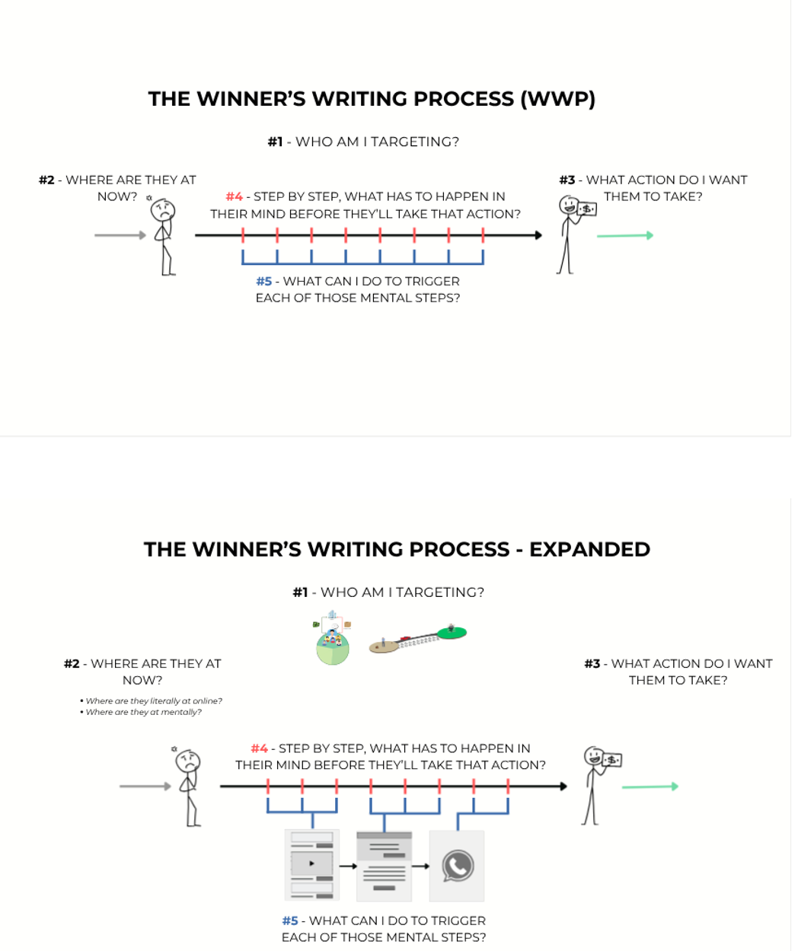

Now, these are 5 simple questions you ask yourself, and you ask yourself these questions in order.

And the answers you get will basically give you your entire strategy, your plan, and the outline of what your copy, your marketing has to do to get people to decide to buy.

So we walk you through all 5 of the questions and over the rest of the course, basically, I'll teach you how to get really, really good at all 5 of them so that you can produce marketing assets that claim giant chumps of your target market.

Let's dive in.

Number one, you gotta ask yourself, who am I targeting?

Now, at this point in the story, we've done that.

We know who our target market is.

And the whole point of the entire thing, is we have been learning about who we are targeting.

We know, very specifically, it's not just women who want to get fit.

It's a very specific group of people, dealing with a very specific type of problem going to a very specific dream state.

We know it.

We know who they are.

We know their words, we talk to them face to face.

We've broken it down, we know exactly who we're targeting.

That's number one.

Step number two, where are they at now?

So this is their sort of current state.

Where are they at now?

Mentally.

Oh, let me come back to the right screen.

Boom.

There we go.

Mr. Producer did right.

So the second question is, where are they at now?

And we're asking ourselves, basically, where are they at mentally?

Where are they at?

Have they discovered their problem yet?

Do they know about a solution?

Are they sitting around thinking about it?

Are they just going throughout their day?

Where are they at?

What is their current state?

It's sort of a combination of mentally where are they at?

And then also kind of physically, where are they at?

I mean, not literally, physically.

I don't need their addresses or anything like that, but I need to know if they're just going throughout their day.

I need to know if they are actively searching on Google to try and find the answer to this problem.

We need to know kind of generally who we're gonna be targeting and, you know, where they are at right now.

The next question, over here number three, is what action do I want them to take?

Do I want them to buy?

Do I want them to subscribe to my YouTube channel?

Do I want them to subscribe to this?

Do I want them to watch this?

Do I want them to show it to an event?

What is the actual specific example, like action I want them to take?

In this case, right, we know who Linda is targeting.

We know kind of where they're at, or we will explore that in the rest of the story.

Then the action we know, we kind of want them to show up and try out this class and sign up and become a member of her Pilates studio.

That's the action we want them to ultimately take.

For whatever business project, or marketing game you're playing, it might be slightly different depending on, you know, what your scope of work is, but you need to know who you're targeting, where they start off at.

And what action you want them to take, where you want them to go.

At the end of consuming your marketing content.

Then number four, you need to answer this question.

Step by step, what has to happen in their mind before they'll take that action?

So to kind of get them from where they are now to where they want to go, what is their journey?

What is the little buyer's journey?

Now, this should be very familiar to you, since you just learned about the CIA method and understanding their journey.

What are the sequence of events?

What are the little realizations they need to have inside their mind?

What do they need to tell themselves about your product or what have you, before they say, yeah, I'm ready to buy.

You need to list the answer those things out.

Boom, boom, boom, boom, boom. One by one by one.

I still sequence of events.

And then number five, what can I do to trigger each of those mental steps?

Now, this is where you start thinking of how you can what you can show them, whether it's images, videos, words, ads, sections.

All the things you can do that can create those mental effects inside of their mind.

And we're gonna go over this in great detail.

Let me show you very quickly, kind of an expanded version of this.

So again, who am I targeting?

Where are they at now?

What action do I want them to take?

Step by step, what has to happen in their mind before they'll take that action?

And then what can I do?

Like, what little chunks of content or web page or phone conversation will trigger those things in order to get them to buy.

Once you have these things listed out, once you know who you're targeting, all that stuff, you have a list of the sort of mental effects they need to have and the ways that you're gonna potentially trigger those things, you're gonna be able to write.

Instead of being stuck and just trying to combine information, well, now you've taken all that information and you'll be able to process it in a way that allows you to orchestrate and engineer your online marketing content to take people, catch their attention. And give them to want to buy.

Now, over the next few lessons, I'll teach you how to go and answer this question in great depth.

I'll teach you how to plan out this one.

I'll teach you how to figure this out.

A couple of cheat codes to make this really, really simple for you so you can understand exactly what needs to happen inside of their mind.

You're gonna find yourself doing this winter's writing process both on a large scale, planning out your entire marketing funnel, and you're gonna do this on a very, very small scale.

You're gonna do a little miniature version of this for each ad.

And you're going to see lots of examples of it here in the course and get lots of practice with it.

But this is essentially our skill.

This is what we do as strategic marketers to a reverse engineer, the methods and the assets we need to produce to get people to go from where they are now to want to buy.

Going through this process is what's going to allow us to take all that information we gathered about our target market and use it to craft the best possible marketing message, grab their attention, convince them to buy, and do so better than any potential competitors our target market may be exposed to.

So buckle up, pay attention to the rest of the course.

I'm going to show you how to go through the west of the winter writing process.
WWP Questions”

WWP question 1 is answered. You know who you are talking to. Women going through difficult times. They know something is wrong. They are not actively looking for a solution. They are not thinking about pilates.

Now question 2: where are they at right now?

Not just emotionally. Literally. Where is their attention?

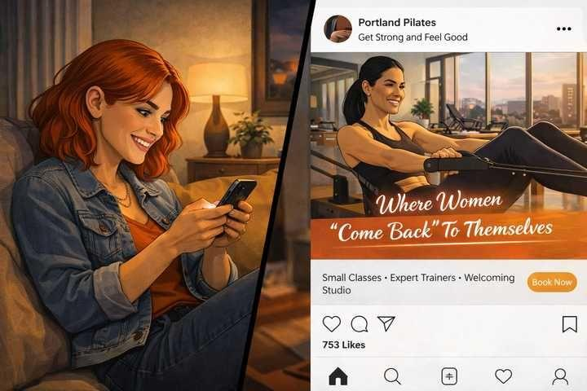

You think about your market research and the women you talked to.

These women are not searching "pilates studio near me." They are not looking for a solution. They are going through their days. Scrolling social media between tasks.

Then it clicks. That reminds you of what the Portland studio was doing.

Social media ads to a landing page with an intro class experience.

The top player already validated this structure. They figured out that this audience is scrolling, not searching, and built a funnel to meet them there.

🛑 THE WALL 🛑

If they are not searching, you cannot wait for them to come to you. The solution has to find them where they already are.

But how you start the conversation depends on how aware they are of their problem and whether they have connected it to any solution.

You need to understand where they are psychologically before you can decide how to reach them.

Below is our Professor Andrew’s Comment:

“WHERE THEY ARE NOW

All right, so let's take a look at answering these questions inside the winners writing process.

We spent a lot of time, like I said, answering number one, we're pretty good on that one.

Let's move on to answering number two.

Where are they at now?

So, it's our job as marketers to find find our readers where they are now, grab their attention, sync up with the conversation that's happening in their brain, and then take them to where we want them to go.

But if we don't sort of intercept them perfectly at the right moment and match up where they're at now, ended up talking to them in a different way, then nothing else we do really matter.

So we really need to figure out where they are now.

Now, there's two sides to this, where they add mentally, and where they're, like, literally online.

And both of these are gonna be important.

And when you answer both of these questions, it will it will tell you how to go and get their attention, what tactics, what strategies, what platforms to use.

So I'm gonna walk you through 2 of the main considerations beyond just sort of knowing their who they are and the stuff that your market research and CIA insiders told you.

I'm going to talk to you about how to plan and understand mentally where they are so you can approach them the right type of marketing tactic, grab their attention.

So let's start with understanding, 1st and foremost, their awareness level.
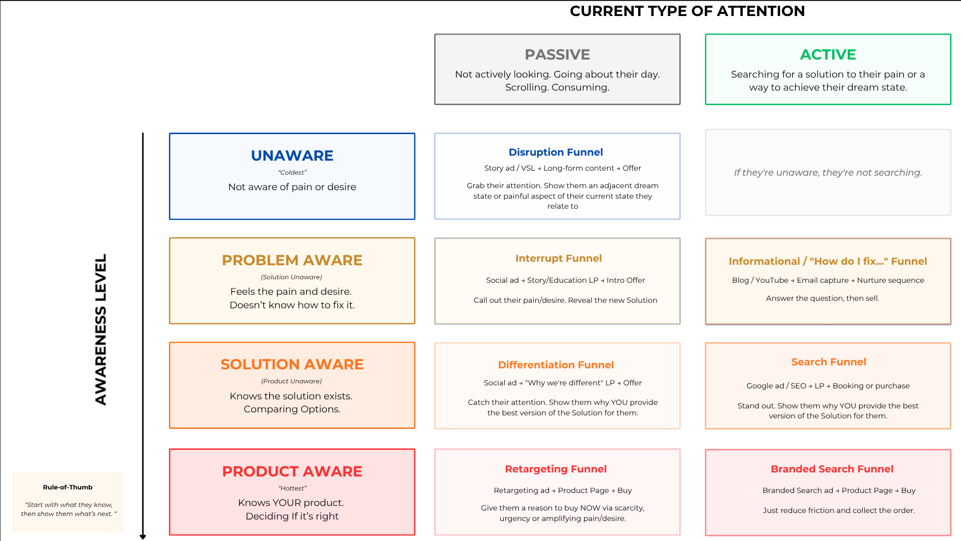”

Now, apologies, I am zoomed in here because when we combine these two concepts that we're about to describe, it's going to create this really cool thing that's going to help you pick a pick a strategy of, like, flawlessly every single time, so you can make sure that you grab your target market's attention.

So bear with me for the full review.

We going to stay zoomed in for a second.

So, First things first, let's talk about how aware they are.

Now, your target market is, is either, they're only gonna be so aware, right?

They're only gonna know so much about, and we come back here and take a look at kind of this old diagram here.

Like, sometimes they'll know, they'll know about their current pain states.

They'll know about their future states.

They might know about some of their roadblocks, but they might not.

They might not know about all their roadblocks.

I might not know about all their solutions.

They might not even know that they can get this cool fun experience, right?

They might just be unaware of some of those things.

And knowing exactly what they already know is going to tell you where to start the conversation.

So let me go through.

There a few levels you need to kind of pay attention to.

You're going to be able to categorize your target market and at least the people you're going after into one of these categories and it's going to inform your strategy.

So, The the 1st one is like completely unaware.

This would be like the coldest possible traffic you could go after.

This is someone who's not really aware of that particular pain or desire.

Now, this is, this is really, really difficult, and this is basically, basically none of you are gonna go after this.

This is this is questionable.

Half the time someone thinks that they're in, they're going after unaware market.

They're going after a target market that doesn't exist.

Basically, ignore that one.

That's not going to be something you're going to basically ever touch in your marketing career, at least not the 1st 6 months year of your copywriting career.

If you ever do find yourself dealing with this, what you're going to find yourself, you're going to end up real quick, just sort of, um, spilling the buckets and or kind of spilling the beans here, giving you guys an advanced peak here.

If you ever do find yourself in a market where they're unaware of how bad their life is, you're gonna solve that problem by showing them something new and cool that's related to what they want or showing them a threat or a danger that they were unaware of.

And that's where you're going to start the conversation.

But anyways, ignore that, because you're basically never gonna see that for probably the next 6 months.

Let's go back to the next, let's go back to the next stage here.

The next one would be people who are problem aware.

They know they have a problem, they know there's an issue, but they're not solution aware yet.

They don't know how to solve this problem.

They just know their life kind of sucks.

They're just kind of going through and dealing with this pain or they have this desire, but they don't know how to fix or how to achieve their goal.

That's problem aware.

Then there's solution aware.

These are people who know they have a problem, know what they want.

And they know the roadblocks, the things that are keeping them from getting there, and they even know the potential ways that they can solve this problem.

Those are people who are solution aware.

They just don't know about your product, your business, and your way of helping them.

So that's solution aware.

And then the hottest form of traffic or the hottest audience you can go after is someone who's product aware.

These people, not only do they know about their dreams, and their desires and their pains, and the roadblocks, and the solutions, but they also know about your business.

And they either like or don't like your business, but they know about your business.

And then this is gonna be the easiest...

This is like someone who walks through your front door ready to try your Pilates class in the story.

Their product where they are, it's time to freaking close.

You need collect the order.

So, you need to know roughly what segment your target market is.

Your target market will probably be problem aware, might even be solution aware, might be product aware, you need to figure it out.

All of your CIA insider conversations should cue you in in this information.

And your market research should clue you in very quick, click, quickly into where your target market is.

In this case, I bet you guys could all pretty much guess where Linda's target market is.

They're not unaware.

They know something's going wrong in their life.

They kind of know where they want.

They're problem aware.

Yeah, I'd say they're at least problem aware.

They know that there's something wrong in their life.

The fire has gone out, they feel sad and tired and ignored.

Are they solution aware?

Hmm?

Maybe not.

I mean, they probably heard of Pilates, but they might not be thinking of Pilates as the answer to this gaping sadness and void in their life.

Hmm, okay, so maybe they're problem aware but solution unaware.

So this is the first part of answering this question over here in the winter's writing process.

Where are they at now?

It's kind of understanding where they're at mentally.

Are they a problem, where, solution, where, et cetera?

Because that's going to dictate how you start the conversation.

Let me let me go back over here.

I'm going to say one last little thing about the awareness level and then we're going to talk about where they're at online.

So come back over here to the awareness level.

The rule of thumb, whenever you're trying to catch somebody where they are, is you start with what they know, then show them what's next.

So, if they are problem aware, like they are in this story, the way you would catch their attention is you would say, hey, are you dealing with insert their problem here?

I say, oh, hey, that's my problem.

And then, you'll go on and the rest of your marketing, introduce the solution, and then, once they know about the solution, then you're gonna introduce the product, and decide, and end the offer, to come in and try this out, or what have you.

You start with what they know and you start going down this chain.

So, you know, if they're completely unaware, you show them that drain, that new dream state, then show them what's keeping them from getting it, then showing them how to solve that, and then say, buy my product, you know, that's gonna be the game.

You're gonna take them from wherever they are now to where they need to go.

That's why I have this nice illustrative genius arrow right here.

So let's not talk about where they're at online.

There's basically 2 types of attention online.

There are people who are, their passive attention, and then there's people who are active attention.

So the big difference is, passive is just people, they're not actively looking to solve their problems.

They're just going throughout their day.

They're scrolling, they're driving, they're watching a video.

They're just chilling.

They're just going through their life.

They have all these problems and desires, but they're kind of on the back burner now.

They're just chilling, right?

That's passive attention.

The other category of attention is active attention.

So when people have an issue, you know, they have a problem.

Let's go back to this really zoomed in version of this mega, what I call the mega diagram.

They have a terrible problem.

There's shit in their oasis.

They don't like their life, and they want to have something different, and they actively go and try and solve the problem. Actively searching for solutions.

They're Googling stuff, they're researching, they're going out to try and find it.

Those are 2 different types of attention.

They're either active or they're passive.

Now, in this case, we can take a look, and I guess we'll break this down for, I can give you some examples.

So in our case, like Linda's customers, I mean, they're just chilling, right?

They've got their terrible life.

They're busy.

They're not really actively trying to solve it.

They're just chilling, you know?

They're going through their outdoor life.

They might scroll a little bit.

They might be busy working.

They're not actively searching.

How do I solve my depression, sadness, and being alone and fat?

You know, they're not trying to solve that problem.

Most of them.

Then there's active.

This would be more like you, you come home from work, you walk in, your apartment, and your home.

And there's a giant, your kitchen floor is covered in water.

There's water everywhere.

There is a giant plumbing link under your sink. Gets broken.

You're going to actively go search for a emergency plumber near me, call them up, and get them to come over here and fix your problem.

Active attention is when they're actively trying to solve their problem.

Now, sometimes it's from these emergencies, but whenever the pain or the issue becomes very acute, usually they'll go and actively start to try and search out how do I solve this problem?

How do I get this?

Or what product, like, where can I find this product?

Where can I buy this thing?

And they'll usually get it sorted correctly.

So it was the 2 different types of attention.

Now, in the story here, we're dealing with passive attention, but you'll find yourself oftentimes dealing with active with a lot of your clients and businesses that you work with.

So just pay attention to both of these.

But that's the other side of the equation to the, excuse me, where they're at now.

You kind of know where they are, what their awareness level is.

We already know who they are, what they think, and all their internal dialogue.

We already know all that stuff.

We also now know where they're at online.

Are they passively just consuming content or are they actively searching?

They actively searching out some answers.

So, once we have that, those two pieces of information, it's gonna give us a bunch of...

Well, it's gonna give us a big cheat code.

It's gonna allow us to know exactly how to catch their attention, the strategy that we're gonna put together and use.

So, if they're unaware, we're gonna grab their attention with a disruption funnel, and most of this guys, I'm gonna leave you this diagram.

It's mostly for reference, you can go check it later, you can go look for examples of this.

This is this is something you guys are gonna be able to reference for the rest of, you know, your life, for whatever project you're doing.

But let me just show you a couple of the really common ones that you will find yourself doing.

So let's look at Linda's situation.

So, Linda's situation here, we know that the the audience is problem aware, they're not solution aware.

So they're right here.

We know that it's passive attention.

We're gonna create an interrupt funnel.

So we're gonna run social media content, ads, put content under whatever platform they're chilling at, either organic content or paid ads.

And we're gonna use that to catch their attention, and we're gonna talk to them about their problem.

Then we're gonna show them the solution, and then we're gonna convince them to come in and use the actual thing.

So, the interrupt funnel, you'll have social content, and then usually you'll drive them to a landing page or a sales page for the businesses website, where they'll become a customer.

That's an example of interrupt funnel.

Let's look at a couple other ones.

Let go back to the plumbing example.

So for people who have an active problem, or they're actively searching for solutions.

Now, if you come into your room or your house, and it's covered in water.

Oh no, big emergency.

You're going to be problem aware.

You're gonna know, oh, no, there is a giant problem here.

You're gonna be aware of that?

Solution aware.

Do you know the plumbers exist?

Yes.

So, you know, I can have an, I can have a professional plumber come in and fix this.

You're gonna know that.

Some people might even say, I'm gonna have my buddy Steve, the plumber.

Who's that guy, Steve, the plumber?

Yeah, Steve the plumber.

I my buddy Steve, the plumber.

Um, come and do come and fix this.

They're gonna call directly.

But if they're just solutionalware, I need a plumber.

Which plumber should I get?

Let's see, so active attention, solution aware.

Ah.

Search phone.

So, this is where you'll run Google ads or have Google my business listings, or maybe even do some AI search stuff.

That more advanced.

I teach you guys all this these fun advanced funnels later in the course.

Don't worry.

You see examples of all of these in the resource and stuff as you carry on in the course.

Anyways, but let's say, okay, really simple.

If you were going to help a plumber, catch that guy's attention, the emergency guy's attention, you'd help him set up Google ads where you would talk about how, hey, we're a plumber and why you're the best plumber.

And then you drive them to a landing page and have them either call you directly or book a free quote or book an emergency plumbing service.

Now, interesting.

Okay.

Cool.

That's the game, right?

And again, there's other versions of this.

If they're not solution aware, if it's a less urgent problem, you can go over the information, how do I type one?

All of this is like fun little references.

This doesn't really exist.

Active attention for unaware problems.

That doesn't really exist.

But all of these other ones, these are gonna be sort of the overarching strategies you'll use to catch their attention.

And then continue the conversation, get them to lie.

Now, in the rest of the lesson, like you'll see these playout in the story, you'll see kind of the student go through and discover which way is going to match you with Linda's situation.

Later on, though, now, we're going to start talking more about how to actually get them to the point where they're ready to buy and the things that have to happen inside of their mind to make that happen.

So pay attention, and this is gonna be really, really useful.

We're in the meat and heart of the actual course right now.

So this is the stuff you're going to be using.

Hopefully you're taking careful notes and getting ready to apply this to your own stuff.

We got a lot of fun, little tweaks and twists.

Once we get into especially 4 and five, that's where it gets really, really powerful.

This is where you start to get a huge edge over everybody else.

So pay attention.

Let's go.

All right, so.”

Question 2/2
FUNNEL SELECTION

Linda's audience knows something is wrong but they are not thinking about pilates. They are not searching. They are scrolling social media.

The Portland studio already runs this exact type of funnel. Which structure matches where this audience is?

- A referral program where current members share a discount code on social media, since warm introductions from trusted friends are more persuasive than any paid advertising

- Google search ads targeting "pilates studio near me" with a direct booking page, since that captures people at the exact moment they are actively looking for the solution

- A social media ad that names the feeling they are living in, leading to a landing page that bridges the gap, since they are not looking for a solution and you have to find them where they already are

- A weekly email newsletter about wellness and self-care that gradually introduces pilates as an option over the course of several weeks of nurturing content

Answer no:3

CORRECT ✅

They are not searching. They are scrolling.

The solution has to find them where they already are. The Portland studio already proved this works for this exact market.

Social ad to interrupt, landing page to bridge, intro offer to convert.

______________________________________________________________________________

Question 1 is answered. Question 2 is answered. On to question 3.

What action do you want them to take?

Your first instinct lands fast: book a class. Maybe with a discount to lower the friction. You type it.

Then you stop.

You pull up the Portland studio's funnel again. Their entry action is not a booking. It is not a discount. It is a free discovery class.

You think about Sarah scrolling at 9pm on the couch. Would she buy a 10-pack from one ad? Would a discount change that? No. A discount on something she still is not sure she wants is not a deal. It is a bribe with no reason to care.

You change your Q3 to match Portland. Free discovery class.

But why does a free class work when a discount does not? Something about that is nagging at you. You need the next step of the process to understand it.

winners_writing_process, Questions
Winner’s Writing Process
Answer these five questions before you write a single word.
Fill this out for the full funnel first. Then zoom in and fill it out again for each individual asset.
No guessing. No winging it. Engineer the experience.
Client / Business

Project Type (ad, landing page, email, full funnel, etc.)

Question 1: Who Am I Talking To?
Describe your target market as a real person. Psychographics, not just demographics. If you can’t picture their Tuesday afternoon, you haven’t done enough research.
The person in one breath (age, life situation, what defines their daily experience)

What do they want most? (Dream state, in their words)

What do they hate about their current situation? (Current state pains, specific)

What’s stopping them? (Roadblocks, the real ones)

What have they already tried? (Previous solutions, why those didn’t stick)

What language do they use? (Direct quotes from reviews / CIA interviews)

Question 2: Where Are They Now?
Two dimensions. Where are they psychologically (awareness level)? And where is their attention (searching or scrolling)?
Market Awareness Level (circle one):
Unaware > Problem Aware > Solution Aware > Product Aware
Evidence for this assessment (what from your research supports this?)

Attention Mode (circle one):
Active (searching for a solution) Passive (scrolling, not looking)
Where will you reach them? (Specific platform / channel)

What is the conversation in their head right now?

What are they afraid of? (Related to the buying decision)

Question 3: What Do I Want Them To Do?
One clear action. Not “engage with the brand.” A specific, measurable action. Then identify the biggest threshold standing in the way.
Primary desired action

What does success look like? (They clicked, they booked, they bought. What exactly?)

Threshold Assessment
Before your marketing, where does the reader start on each? Where do they need to be?
Desire: starts at ___/10, needs to reach ___/10
Certainty: starts at ___/10, needs to reach ___/10
Trust: starts at ___/10, needs to reach ___/10

Which threshold is the biggest gap? This is where you focus the most firepower.

What closes that gap? (Direct experience, proof, risk reversal, etc.)

Question 4: What Are the Mental Steps?
List every internal step the reader has to take between where they are now (Q2) and the action you want (Q3). These are the thoughts and feelings that have to happen in sequence. If a step is missing, the chain breaks.
Mental Step (Q4) | Threshold | What she’s thinking / feeling
Step 1:
Step 2:
Step 3:
Step 4:
Step 5:
Step 6:
Step 7:

The rule: every step on the left needs a trigger on the right (Q5). If you can’t name the trigger, the step doesn’t happen.

Question 5: What Are the Triggers?
For each mental step in Q4, name the specific external thing in your marketing that causes it. This is where your CIA research and top player breakdowns become concrete.
Mental Step (from Q4) | Trigger (Q5) | Where does this appear?
Step 1:
Step 2:
Step 3:
Step 4:
Step 5:
Step 6:
Step 7:

This doc is your battle plan. Every minute you spend here saves you hours of writing copy that does not work.

How To Get Them To Buy


You have her avatar. You know where her attention is. You know the action you want.

Now the real problem.

She is a stranger. She has never heard of Linda's studio. Her back hurts but she has lived with it for months. She is scrolling on her couch at 9pm.

You need her to get up, put pants on, drive across town, walk into a room full of strangers, wear tight clothes, and try something she is not sure her body can do.

The more you think about it, the more daunting it seems.

What has to be true inside her head before she does any of that?

Below is our Professor Andrew’s Comment:

“THE THREE THRESHOLDS

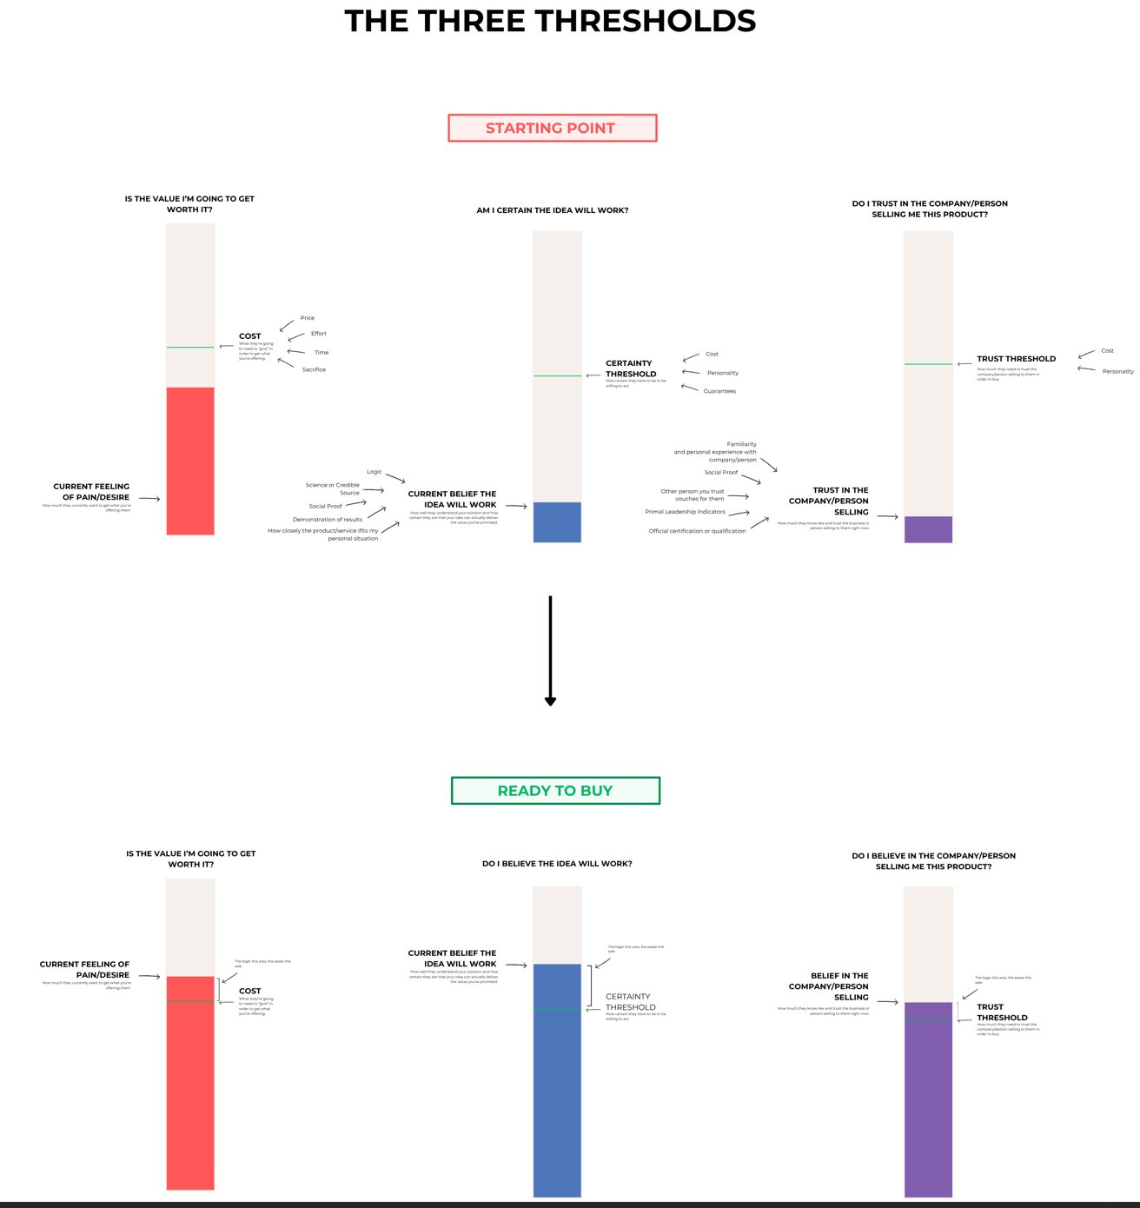
Okay, so let's take a close look at, we've answered number one, we've answered number two.

Let's look at answering number three.

What action do I want them to take?

And step by step, what?

And we're going to kind of look a little bit into step by step.

What has to happen in their mind before they're ready to take action?

So, human beings are interesting in that we are wildly different, but also, at the same time, our basic wiring the way that we think through problems, the way that we make a lot of our decisions.

They follow, we all follow basically the same equation.

We all follow basically the same pattern.

If you understand that pattern, it gives you a huge advantage because you can engineer exactly what has to happen in their mind for them to say yes, side to buy, side to purchase, and all that stuff.

So let's take a look at it.

So, I have a concept that I've created that has, this is how I literally think about this inside of my brain.

This is how people decide whether or not they're going to buy or take an action that you recommend.

And they're going to run it through these 3 pillars, these 3 thresholds, and there's a few levers you can pull here.

I'm going to cover this at a very high level today.

And then as you progress later in the course, get into the advanced persuasion content, I'll go into deep, deep, deep dives of every single element here, but this is essentially how someone will decide whether or not they're going to buy.

There are sort of 3 questions that exist inside of their mind.

And if you can get them to say yes to all three of these questions, they'll decide to buy.

The 1st one is, they'll ask themselves, is the value I'm getting or going to get worth it?

So every time you ask them to do something, like make a purchase, or click a link, or what have you, there's a projected, in their mind, they're gonna be...

You will have offered them something that is valuable to them.

Hey, click this link to learn about this, or hey, buy this class, to experience whatever.

Whatever that thing is you're offering them, they need to know if that is valuable to them, like how valuable it is.

If it's kind of valuable, it'll be down here, if it's very valuable, it'll be up here in their mind.

How well you've been able to convince them that it's valuable, we'll also have to do with that.

But this is really their current feeling of pain or desire.

So we all know they have desire.

We all know they have current state, things that they don't like about their life.

You're gonna catch their attention, and you're gonna do what you can to elevate this, and make them want to want to do this.

And you really want them to get over this little level here, the cost level.

So every action that you recommend has a cost.

If you ask them to sign up for a class and pay 100 bucks for a class, the cost is $97.

And they have to believe, they have to feel in the moment, to feel so much desire that to feel like their desire is greater than the cost.

I want this thing, the value I'm gonna get out of this action that I'm taking is gonna be so much more than having this 97 bucks or whatever.

So, your job is to get, to increase the current feelings of pain or desire around whatever you're talking about.

And also decrease their perceived level of cost.

But you're gonna do everything you can to get them to believe, yes, this is valuable, this is super valuable to me.

In fact, this is more valuable than taking this particular action.

That's the first lever.

Is this value, I'm going to get worth it.

The second one, and the second sort of question they ask inside of their brain.

And this is, you know, once this has been answered in their brain, this is gonna be the next one that really matters.

This is, am I certain, the idea will work?

So whenever, or the idea, product, service, am I certain this is gonna actually give me what I want?

And you're gonna want them to believe beyond their sort of certainty threshold.

Now, if you might offer something really, really nice to someone, say, listen, um, I'm gonna give you a Ferrari, uh, it drives really freaking fast.

You'll look really, really cool in it.

Blah, blah, blah, blah, blah.

The desire might super be there.

But if the pictures you show them of the Ferrari, make it look like it's broken. Then they're not gonna really, they're not gonna believe that it's really gonna, it's really gonna work.

They don't believe that it's actually gonna give them that value.

So even though they super want a Ferrari, and they want to look like a badass and drive around really cool.

They're not gonna buy from you because they think, Eh, I don't actually believe that car can do it.

I don't believe that act, that actually car matches my the ability to do this.

Whatever solution you recommend, whatever action you recommend they take, they have to believe that it's going to pay off.

Now, sometimes, some people, they have very low, certain thresholds.

I mean, just do some very, very quick diagram, I keto here to make this look really cool.

I know if I'm gonna be able to pull it off.

Some people, yeah, I'm pushing the wrong, they're pushing the wrong button, but I think we'll figure it out now.

There we go.

Some people, almost.

There we go.

Some people, I want to move the entire pillar.

I'm pathetic.

Some people, they're starting thresholds a lot lower.

And you can get them over the edge.

They don't really need to care.

They don't really care too much about it.

Or, you know, the price that you're asking for it is so, is so low anyways.

This right here is so low anyways, that they don't have to really believe it's worth the gamble, the cost is so low, they might as well just check it out.

Um, but you're gonna want to get their certainty threshold above that cost.

Or you want to get their current belief in the moment above that, and you're going to do that by, you know, using logic, sorting credible, you know, citing credible people, showing social proof, showing other people to do this, et cetera.

But you're gonna try and boost their belief in the moment that that thing is gonna give them what they actually want.

And then the 3rd element, this 3rd pillar, is, do I trust the company or person that's selling me this product?

So, to go back to the Ferrari example, you might show a really cool Ferrari.

Let's say, you say, give the person, they find someone who super wants to drive a fast car and look cool, right?

You've amplified it by showing them this beautiful picture of a Ferrari tearing around, like, coming down into Monaco, like the golden eye opening.

You've helped them discount the price and effort in their brain.

They super believe that the Ferrari vehicle is legit.

They believe that it's the best one ever.

You've got them super amped up.

They're excited.

But you're a sleazy scale salesman.

And, like, you've got, let's say you're missing a tooth.

Let's say a homeless person.

It turns out you go to pay for the car, and it's a homeless person trying to sell you a Ferrari.

Your likelihood of forking out the money is very, very low.

Your trust, do you believe, do you want a Ferrari?

Yes Do you believe the Ferrari will get you what you want?

Hell, yeah.

Do you trust this homeless person that's trying to sell you a Ferrari?

No.

So, people need to believe that the person they're interacting with the business they're interacting with is trustworthy.

They're actually gonna deliver the promise.

They're gonna show up on time.

There's not gonna be hidden problems.

They need to know that they can trust a business.

Now, there's a lot of ways you can increase the way that someone will perspect the trust that they're gonna have.

Just building up the familiarity with them over time, social proof showing that a lot of people have purchased from them as possible, having a bunch of reviews prominently shown.

Having someone that you personally know vouch for them or someone else that you respect vows for them.

Basic primal, this is a film with primal leadership indicators.

So if the person selling to you does look homeless, they look tan, fit, like they just came from Monica.

Then you're gonna more likely believe them.

You know, they look like a leader, you'll trust them inherently.

And then, of course, having an official certification or qualification really helps.

But you're gonna do, when you are trying to get someone to purchase something, let's go back to the winner's writing process real quick.

When you're trying to get someone to take an action, the bigger the action you're trying to get them to take, and go, again, back to this diagram, the other one, the thresholds diagram.

The bigger the action you're trying to give them to take, the more money you're trying to get them to spend, or, you know, the bigger the commandment, show up for this event or what have you.

The greater the cost.

The greater the cost and generally greater the certainty threshold, the needs to happen, and greater the trust threshold.

If you ask somebody, like, for example, let's say you were running a boarding school for children of the elite.

You would need to pass, like, A, the cost would be very, very hot, but their certainty threshold and their trust threshold would be at the very, very top.

And you have to give them all the way up to the very, very top.

Whereas if you're asking to watch a two minute video, well, the threshold's a lot lower.

So, when you pick an action, you need to bear in mind the threshold that you're gonna pick.

Some people try and do too much too quickly.

So they try and sell a $10,000 course after watching a 15 minute ad.

Well, it might take longer than that and greater exposure to the brand to get them to have their trust threshold higher.

Or to, they might need to see the thing play out a couple of times and have a couple of days to think about it before they're certain that it's actually gonna work.

So, when you're deciding what action you want them to take from your funnel, you need to act accordingly.

You need to plan a cost that's gonna be achievable in the, at least for the chunk of the marketing assets and the funnels that you're gonna build.

In this case, it's pretty simple.

You're gonna be able to see some examples of how to do that in a story here.

I'll give you some other examples, especially as you get into the advanced persuasion tactics.

I'll help you figure out how to play with all of these levers a little bit more.

But you need to think about the thresholds.

And once you've established what the thresholds are gonna be, once you've got this question answered over here, you know what action you want them to take.

Well, you're gonna kind of be able to start, You're gonna be able to start estimating what those thresholds are.

You'll be able to say, hmm, well, I think the cost is, you know, it's relatively high and there's 30 threshold has to be here.

Yip, yip, you'll be able to estimate that.

And then you'll start kind of going back and ask yourself, okay, when they 1st start out, when I first find them scrolling on their couch.

How strong is the current feeling of desire?

Is it down here?

Is it up here?

Where exactly is that?

And you're gonna kind of roughly guess, again, this isn't, like, math. Is subjective.

But you're gonna kind of guess, okay, it's down here, but I've got to give them way more, I've got to give them their current feeling of pain higher.

How can I do that?

You're gonna figure out what the thresholds are, but you're also gonna figure out what their certainty levels are as well.

And they're trust levels.

You're gonna figure out where they are, and then your job, the point of the rest of your marketing, from your ad, all the things that it has to do, you need to get these thresholds, or get these levels above the threshold.

You need to boost their current feelings of desire above that cost.

You need to help them believe that it's truly gonna work and get them what they want.

You gonna have to increase their trust in you as a business in order to get them there.

Now, everybody you talk to is gonna start off with slightly different things, different funnels or different strategies you use are gonna have different, different levels here, and it's your job to sit down before you plan out your outline before you start running comedy, kind of figure out where the thresholds are, what you're aiming for, and then also where they're at currently with each of these levels.

So you can figure out how much work you need to do. With that.

You want to get people over the edge, and the further you can get them over the edge, the faster and easier it'll be for them to find.

So you're going to want to identify these different thresholds, think about these three big giant mental effects that you're going to create in their brain.

This, these 3 thresholds here, these 3 levels are intimately connected with a lot of the stuff that happens here inside the winter's running process.

So we know who we're talking to.

We know where they're at, we know what the starting thresholds are at.

We know where they're at mentally.

We know what awareness level they're at.

You know the right strategy to get in front of them.

We know we've decided that action, we're gonna have them to take.

And now we're starting to figure out, mentally, some of the changes we're gonna have to achieve in their brain before they cross the thresholds before these levels, cross the thresholds, and they're ready to buy.

“

Question 1/2
THE BIGGEST GAP

Based on the CIA interviews, which threshold is the biggest gap to close before Linda's audience will even book a free class?

- Desire: they have suppressed their needs for so long that the want needs to be reignited with vivid emotional language before they will consider any offer at all

- All three are roughly equal for this audience and each element of the funnel needs to address all three with the same level of emphasis and attention

- Trust: they have never heard of Linda and building trust requires repeated exposure over time, which a single landing page and one ad cannot deliver on its own

- Certainty: they have tried things before and quit, and they do not believe this time will be different, so the copy has to dissolve that specific doubt before they will act

Answer no:4
CORRECT ✅

Right. Desire is alive. Trust can be built in person. Certainty is the wall.

Every word you write has to dissolve "will I follow through this time" before she will eve

_______________________________________________________________________

🛑 THE WALL 🛑

You know the thresholds. You know certainty is the gap.

But a threshold is not something you cross in one jump. It gets crossed in steps. Tiny movements inside her head, one after another, until the bar finally lifts above the line.

You need to map those steps. And you need to know exactly what to do to cause each one.

Below is our Professor Andrew’s Second Comment:

“THE THREE THRESHOLDS
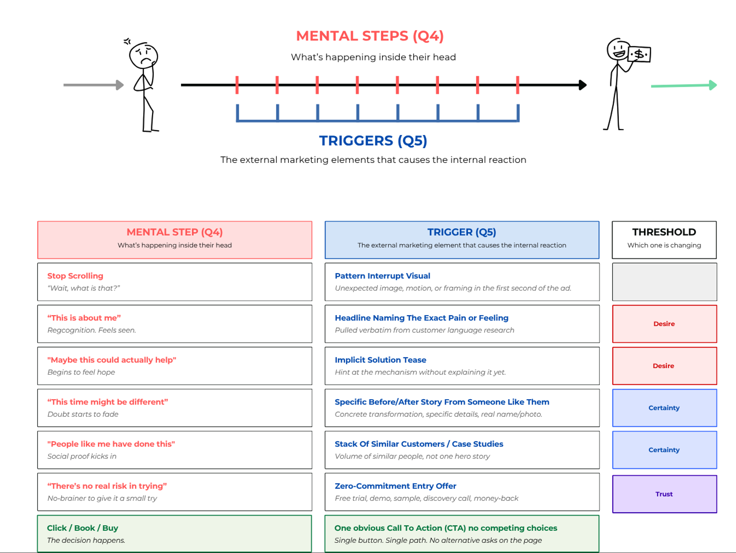

All right, so let's start talking about how to get them from where they are now to where we want them to go.

We've looked at who they are, where they're starting at, what our action is, we understand a little bit about some of the things that need to happen in their brain.

Both start talking about how to actually orchestrate this experience.

So, I like to think of the work that we do as strategic marketers is, sure, it's kind of like, it's kind of like engineering, we're engineering and outcome.

But it's also kind of like we're movie producers or directors in a way.

And let me explain what I mean.

So, if you think of a movie, a movie, people will go, and they'll sit there, and throughout this course of the movie, they'll watch little scenes, little scenes will play out in the movie, of an opening scene, actors, dialogues.

And I things will happen in the store.

And as someone goes and watches this movie, this person, this person who's viewing the movie, they're gonna have all these mental experiences.

You know, watch the movie, they're gonna get excited, they're gonna get scared, they're gonna get sad, they're gonna fuel the resume.

They're gonna get shocked and they're gonna laugh.

They're gonna have all these mental experiences, building up to the climax, and then the resolution, and they're going to have all of this experience.

And if they had a good experience, it was fun and exciting and interesting, they're going to say it was a good movie.

And it's the job of the director, and the writer, and the producer, and all those movie men, whatever their roles are.

To plan out piece by piece, each of the little, each scene, what the angle's gonna be, what the words you're gonna be, what the next scene's gonna be.

Let's put that here.

Let's cut that here, let's do a quick transition here.

They plan all these little triggers, these little scenes and elements that, in order to produce this effect.

And that's sort of their job.

How can we make these little, these scenes and touch points in the movie, so cool and so interesting and in the right order that it creates this, you know, roller coaster ride emotions for the viewer and they get really, really happy and think our movies are great and come back and buy it again.

In that way, our job as marketers is very similar.

We have people who we want to grab their attention, we want them to think surf and thoughts.

We want them to increase their desire, increase their certainty, increase their trust, et cetera.

Make certain choices, answer certain questions in their brain, and then decide to buy.

We have this internal experience we want to create in their brain, and while we can't, like, literally go into their brain and control it, what we do is we create a series of marketing assets, with little elements, headlines, videos, testimonials, links, uh, whatever, whatever, little elements that, if we do our job right, we'll trigger the corresponding emotion, or the corresponding thought, or answer the question, or allow them to draw their conclusion, and then eventually decide to find. Buy.

Piece by piece by piece, everything we do is designed to create a specific effect that takes them from wherever they're starting out to, to being ready to take the action we want them to do without their credit card. And decide to buy.

Now, let me tell you a few more.

Let me give you some examples of how this plays out.

So, if we look at, oh, and I made this charge just to help you kind of understand how these ideas connect.

If we look at, let's say, the mental steps, let's say you're going through, you're doing your winter's running process, you get the question for, say, what, like, step by step, what has to happen in their mind, to get them ready to take the action or whatever, whatever.

You might come up with a couple of things.

You might say, okay, they need to stop scrolling.

They need to realize that this is about me.

They need to realize that maybe this could actually help.

Uh, this time might be different.

People like me have done this.

There's no real risk in trying.

Okay, I'm gonna buy, right?

These might be the sort of mental steps and some of the things they need to think in their brain before they're ready to buy.

And maybe roughly in this order.

Now, you're gonna trigger those, let's say you trigger those, using certain elements in your morphing.

Now, you might not do all of this with, like, just one ad or just one landing page.

Some of it might be split up.

You might do the first little bit with the ad, and the last one will go to the landing page.

But you're gonna say, okay, if I want them to stop scrolling, how can I make that happen?

What trigger?

What thing can I do to trigger them to stop scrolling?

Well, I can try a pattern interrupt visual.

I can use an unexpected image with some motion or whatever, and, bam, that'll give their attention to get them to stop scrolling and look at my app.

Okay.

How can I get them to think that this is about me?

Well, what if I used a headline right here or a phrase that I call an exactly what they're going through?

Like, I'll use the exact words for my customer research and that CIA insider.

I'm gonna use that to call it their pain.

And you can you can kind of see how you can go through and say, okay, well, well, how could I do this?

Well, I could I could do this angle or, you know, how could I trigger this?

And you can start to see how simple it is to start coming up with little moves you can make.

And in the rest of the course, and especially as you get into some of the advanced persuasion tactics, and we do some of the live work that we do inside of the campus, you're gonna build up a giant arsenal, different triggers that create different mental effects.

But once you know what they need to feel and think and experience in their brain to step by step in order to get ready to buy, you're gonna start coming up with ways to make this happen.

Now, you should be able to do this sort of all by yourself, based on your marketing research, based on your CIA insiders, you've already, again, one of the things that's cool about a CIA method is they've told you they're, they told you their internal, internal journey, and they've probably even told you what caused those things along the way.

So you've got a lot of that's already premapped out.

But I'm gonna give you sort of another another bonus cheat code or a way to use this to come up with this outline.

Because once you have this mental step and it's outline, the triggers, once you have this mapped out, that's what you need.

That's gonna be like the outline, the skeleton of your copy, that you're gonna go use to draft out your ad and your landing page and stuff like that.

But there is sort of a cheat code.

There's a way to do this.

And let me go back and kind of circle back to one of our previous lessons, one of our previous ideas.

So, if we come back and think about the market research that we did looking at competitors, some competitors are doing a good job, others are doing a poor job.

But I almost, I recommend you guys always try and find a top player, a business in, you know, maybe a different city or in a slightly adjacent industry or slightly adjacent business type that has done a really good job of getting their attention and talking to them, who has a really good marketing funnel.

Like, this part of their life is extremely, extremely well.

It's working very well.

There's a lot of money coming in, and we know that the way that they're getting attention and getting people to buy, their sort of recipe for doing this is really good.

If you can find somebody like that, well, you can use what they did, scene by scene by scene, element by element of their copy and marketing, to reverse engineer not only the mental steps, but also start figuring out what triggers are gonna work.

It's basically like they've got a really good recipe.

Excuse me, they've got a really good recipe for grabbing the target market's attention and getting them to want to buy.

Let's go use their basic recipe as the starting point and we'll add in our ingredients.

So instead of talking about, you know, instead of saying their business name and their testimonials, we'll use our business name and our unique value proposition and our, um, you know, our testimonials, for example.

But basically what you can do is you can sit down, and instead of starting with a mental steps, what you can do is you can go take a look at one of their online funnels, and here I'll switch over to this other diagram, because I think it might be even more accurate for you.

Like, if you go and look at their ads and then their landing page, and then the call that they get afterwards or what have you, you can go through and break down each of their elements one by one by one.

You say, oh, well, this is what their video does.

There's the 1st 3 seconds, 3rd video is this.

Then they have this word, these words on the ad, and this is where the button says, okay.

And then on the page, the headline says this, then they say that, then there's the section, then there's the buy now section.

Then they get a call, or the person says their name, and you can go through, and you can list out, um, sort of this half of the diagram, or this half of the chart first.

You can list out all the things they're doing successfully.

One by one by one.

Just list out everything that they're doing. Piece by piece.

And then you can reverse engineer and say, okay, well, why are they doing that?

Okay, why do they use that image?

Oh, it's probably because it softens from scrolling.

And then you can fill out what that is.

Oh, why did they have this headline where they talk about the pain?

Of being a working woman, blah, blah, blah, blah, blah, or whatever?

Oh, maybe it's because it's gonna trigger this.

And you can go through and reverse engineer all of the internal mental steps, that you need to get your people to experience, to do the same thing, 'cause if they're trying to get somebody from basically the same place, that you're trying to get your target market from, to go and take the same action that you're trying to get them to take, and they're doing productively and predictably over a long period of time, that might work.

They might know a thing or two about this recipe, and you'll be able to reverse engineer it.

So that's another way that you can use this instead of just figuring out yourself with your market research.

By all means, you might end up doing that.

If you can, go find a top player, look at what they're doing, reverse engineer what's happening mentally.

And then when you go around to write your own version of the marketing assets, well, you just change this up with your own ingredients.

You use your stuff.

You use, in this case, Linda, instead of whatever the Portland studio, you know, does.

Use put your information here, your unique experience here.

You put your unique flavor on this, but you're copying the same pattern so that you can achieve a similar effect.

You know how, you know, most movies follow like the same, like there's like a rough same, like the same heroes journey?

You know, there's a person, living a nice little normal life, then something bad happens, they get a call to adventure, they go on into the unknown, they encounter some difficult challenges.

They undiscover some inherent abilities.

They use that to defeat the big bad boss and save the friends, and then they get the treasure, and then they go back home.

Like, the same, like, the same rough formula for a good movie exists, and you can take that same formula and add your own little tweaks and permutations to it, and still make a very, very good movie, but using sort of the same basic formula.

The same thing goes with the mark, and you can go look and see what's working, the internal mental steps, and just put your own sort of unique twist around it.

So, In the story, you're gonna go and reverse engineer this for Linda.

You're gonna figure out what Linda needs to do or what her marketing needs to do to cast these people on the couch and convince them to come in and buy.

You're gonna do that by reverse engineering, what the Portland studio does, and you're gonna then be ready, once you have that, the mental steps light out, that the person has to experience.

And the rough outline of what those triggers are gonna look like, you're gonna be ready to actually create copy and draft out marketing assets that will work, that will get somebody to go from wherever they are now to being willing to whip out their credit card and buy.”

***

You pull up the Portland studio's funnel again.

Different eyes this time. Not a prospect. Not even a marketer admiring good work. You are an engineer reading a blueprint.

You remember the rule from the lesson. Two passes. First, list the elements in the order the prospect actually experiences them. Just the surface. Then go back and work out what each one is doing in her head.

Surface first. Meaning second.


Pass one

You open a fresh page in your notebook and start scrolling the funnel the way Sarah would. Just write down what you see. No analysis. No guessing at what anything is doing yet.

The ad loads first. You note the image. A woman alone by a window, not a studio shot. The pain line underneath hits harder than you expected. It names the quiet way she stopped showing up for herself at some point, and how no one noticed, not even her. You write it down word for word.

Below it, a tease. No mention of pilates. No studio name. Just that hundreds of Portland women have found their way back through something that does not ask them to become a different person. Then the CTA: "Tap if this sounds familiar." Not "Book a class." Not "Learn more." You stare at that button for a beat longer than the others. You write it down.

You click through. The landing page loads and you move faster now. Headline: "Where women come back to themselves." A list of things women like her have tried and abandoned. A section explaining why those ended the same way. A story from a woman named Rachel. A paragraph about what actually happens when she walks in the door. A single button to book a free discovery class. You write each one on its own line.

Then the last element. The in-studio greeting. The instructor uses her name. References something she put on the booking form. You write it down.

Eleven elements. Inventory done. You have not analyzed a single one.

Pass one.

You open a fresh page in your notebook and start scrolling the funnel the way Sarah would. Just write down what you see. No analysis. No guessing at what anything is doing yet.

The ad loads first. You note the image. A woman alone by a window, not a studio shot. The pain line underneath hits harder than you expected. It names the quiet way she stopped showing up for herself at some point, and how no one noticed, not even her. You write it down word for word.

Below it, a tease. No mention of pilates. No studio name. Just that hundreds of Portland women have found their way back through something that does not ask them to become a different person. Then the CTA: "Tap if this sounds familiar." Not "Book a class." Not "Learn more." You stare at that button for a beat longer than the others. You write it down.

You click through. The landing page loads and you move faster now. Headline: "Where women come back to themselves." A list of things women like her have tried and abandoned. A section explaining why those ended the same way. A story from a woman named Rachel. A paragraph about what actually happens when she walks in the door. A single button to book a free discovery class. You write each one on its own line.

Then the last element. The in-studio greeting. The instructor uses her name. References something she put on the booking form. You write it down.

Eleven elements. Inventory done. You have not analyzed a single one.

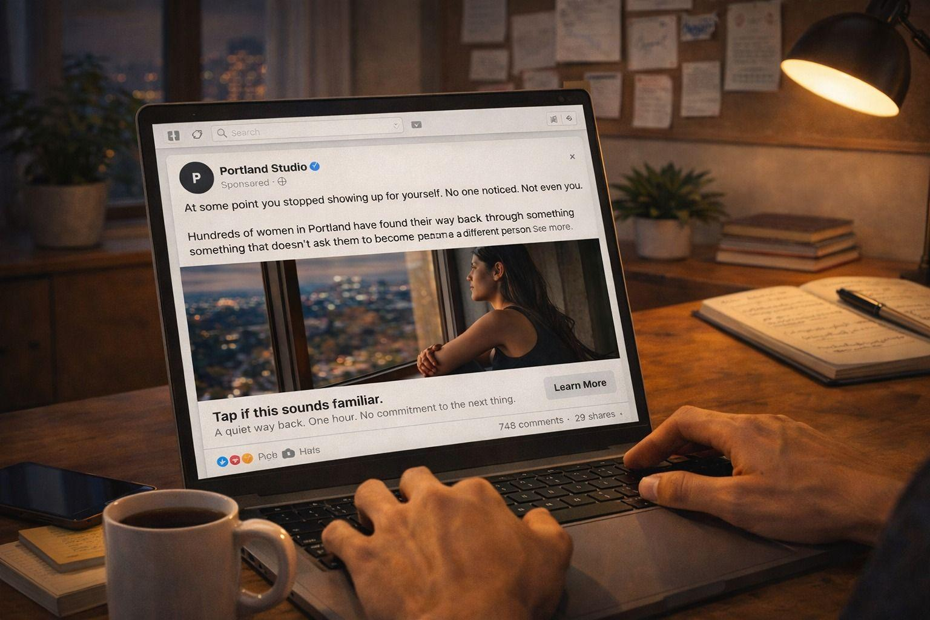

Pass two
You decide to go deep on just the ad before you touch the rest of the funnel. Four elements. If you can decode these four, you can decode the seven that follow.

You pull up element one. The image. A quiet shot of one woman alone. You ask yourself the question: what is this element doing in her head? You write it slowly. The trigger is a pattern interrupt. Every other post in her feed is loud, full of products and faces and claims. This is still. The mental step and effect: she stops scrolling. That is it. That is the whole mental event. Threshold moved: none yet, but her attention is bought. You sit with that. The image is not doing threshold work. It is buying the shot at doing threshold work. That is already a lesson.

Element two. The pain line. You stare at it and try to put words on what it produces. The trigger is a sentence that names a feeling she lives with but has never seen written down. That is the mechanism. The mental step and effect: "this is for me." Identity recognition. The suppressed want surfaces. She moves from "I am scrolling" to "this is about me." Threshold moved: desire lifts. You write that down. You notice the ad is already doing real threshold work by element two.

Element three. The tease. The trigger is that it hints there is a way out without naming it, and it signals that real Portland women are already using it. That is two mechanisms stacked. Mental step and effect: "wait, what are they doing? I want to know." A curiosity loop opens. Threshold moved: certainty gets its first nudge (someone is telling her a path exists), desire stays alive. You notice something. The ad has not sold anything yet. It has not even said "pilates." It is working on her state, not her calendar.

Element four. The CTA. You expected a "book now" or "learn more." It is neither. The button reads "Tap if this sounds familiar." You look at this one the longest. The trigger is that the button language continues the conversation the copy started, and resolves the curiosity loop on her terms. Mental step and effect: "I am willing to keep going. This feels like nodding along, not committing." Threshold moved: trust does not get tested yet, certainty stays neutral. The CTA is an invitation, not a demand. You write a note to yourself in the margin: the ad does not try to close. It tries to earn the click.

Four elements. Four trigger mechanisms. Four mental steps. Two thresholds touched. And you have not left the ad yet.

You spend the next hour doing the same thing for every other element. The LP headline. The failed-attempts list. The why-this-is-different section. Rachel's story. The walk-in description. The CTA block. The in-studio greeting.

Seven more elements. Seven more trigger mechanisms to name. Seven more mental steps to put words on. Seven more threshold movements to track.

You stop flying through it around element seven. The why-this-is-different section. That one takes you twenty minutes on its own. It is the heaviest certainty lift on the page, and once you see why, you can feel how the whole funnel is built around it. Every earlier element is setup for that moment. Every later element is payoff. You make a note: the funnel has a fulcrum.

By the time you finish, you have eleven elements, eleven mental steps, eleven threshold movements. You can trace the chain from first pause to final sale. All three bars cross the line before she walks out of the studio.

You turn your notes into a clean reference doc. This is your skeleton. This is what you will sit down with tomorrow when you draft Linda's version.

DEEP DIVE MISSION

You took notes the whole way through. You turned them into a clean reference doc: the Portland funnel mapped element by element, with the mental step, the trigger, and the effect for every piece.

This is the artifact you will actually use when you sit down to draft.

Open the Portland Funnel Triggers and Effects Map. Read it once all the way through. You are about to build your own version.

Open the Portland Funnel Triggers and Effects Map 👉 https://bit.ly/portland-funnel-ma

Question 2/2
WHY THE TOP PLAYER?

You just spent the time mapping every element of Portland's funnel into the chain. You could have started writing your own funnel from scratch instead.

Why was reverse-engineering Portland's funnel the right starting move before you draft Linda's marketing assets?

- Studying their funnel helps you find the gaps and weaknesses in their approach, which gives Linda an edge over the competitor she will be measured against

- Reverse engineering is general skill-building. The more funnels you decode, the better you get at evaluating ads and pages over time, which pays off across future projects

- It is faster than building from a blank page, which lets you get to the writing stage sooner and gives Linda her drafts on a tighter timeline

- Their funnel has already worked on the same audience you are writing to, so their chain is a tested recipe. You inherit the structural decisions and spend your effort on filling them with your own research language

Answer no:4
CORRECT ✅

The top player has already paid for the testing in real money, real ad spend, real bookings, real returning members.

Their chain works on this audience. The structure is a tested recipe.

Your job is to fill it with YOUR research language, not invent the structure from scratch and hope it crosses the same thresholds.
________________________________________________________________________________

You sit back. Notes all over the desk. Chain mapped. Triggers identified. Portland's funnel decoded element by element.

You have a rough outline on the page. Not copy. Not yet. A skeleton. Ad job, landing page job, offer job. Each one tied to a mental step. Each step tied to a threshold.

You are ready to draft.

Drafting and Review



Home. Alone. Laptop open. Template beside you. Portland studio's funnel pulled up - you already mapped every mental step and trigger in their entire funnel.

You have the blueprint from the WWP. Five questions answered. The top player recipe reverse engineered element by element.

Time to write.

🛑 THE WALL 🛑

You stare at the blank page.

You could reverse engineer the Portland studio's funnel in your sleep. You can look at any ad and tell someone exactly what it is doing wrong. You can diagnose threshold gaps. You can map mental chains.

But writing your own version? That is a completely different problem. Analysis and creation are not the same skill. You know what needs to happen. You do not know how to make it happen one element at a time.

You need a process for turning the blueprint into words. Not all at once. One element at a time.

Below is our Professor Andrew’s Comment:

“DRAFTING
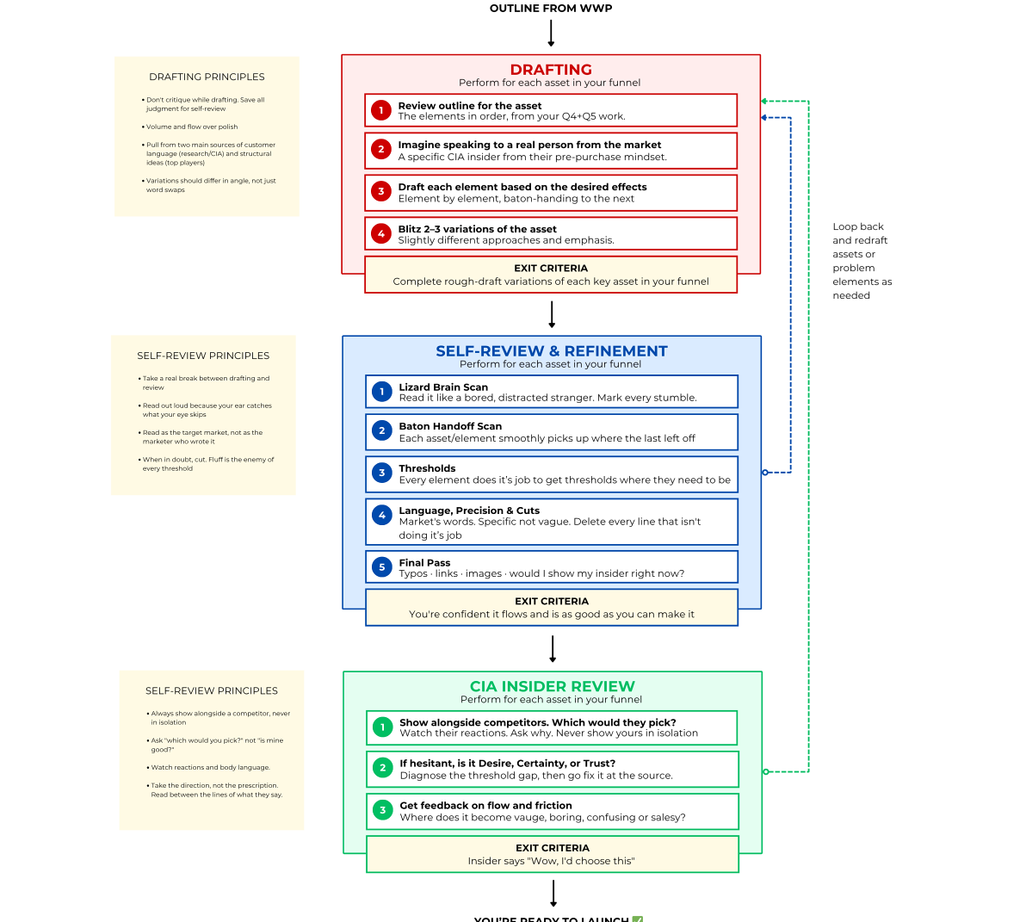

All right, so now that you've gone through and you've got your outline altogether, you know what the top studio is doing.

You reverse engineered it, you now know the experience that you're going to orchestrate for your target market.

You are ready to sit down and actually start drafting and actually start creating the copy that's gonna get them to decide to buy.

Now, there's sort of 3 steps here between where you are now and being ready to launch.

I'm going to cover the 1st one really quickly with you all, and that is like actually drafting out and writing each of the individual assets in your final.

So, you should have an outline that is based off of what you went, you should know exactly what mental steps need to happen in their brain.

You need to have a rough idea of how you're going to trigger those so that they're going to be ready to buy.

You probably reverse engineered this.

You should have that ready to go.

Once you, and you should kind of have that broken up into each, the individual elements, let me zoom in really quick.

You should have that kind of broken up into the individual elements of your funnel that you're gonna be launching.

Your series of marketing assets that are gonna grab their attention to give them to buy.

You might have like an ad and a landing page, and you'll have these different elements from your outline, all sort of listed out in these little chunks.

You know what the ad needs to do. Needs to handle these 3 things.

And then baton handoff over here.

And you'll know what your landing pages do, needs to catch them here, and do this, and this, and this, and this, and then have them ready to go take their action baton handoff there.

You should have that laid out for yourself at this point.

Once you have that outline, once you've gone through everything, you are now ready to start drafting.

So, the 1st thing you do is just review that outline, just like we talked about.

And then number two, I like to, as I sit down to write and whether you're doing like a Google Doc or whatever, whatever you like to write with.

I sit down and I like to imagine that I'm literally talking to the person.

Like a real person, like an actual real person from the target market.

I like to imagine that I am talking to this guy right here, and and not just, like, this guy.

I like to picture their face.

I'm going to super zoom in.

I like to picture the face of the person I'm talking to.

Now, you're gonna probably imagine, like, in this case, you'd imagine, like, Carol, or, like, any of, like, the women that, like, are in the studio.

You're gonna try and imagine that you're talking to them across the table from you, and they're at the stage they were, like, when you're trying to get attention to them.

Like, they're sitting there scrolling on their phone or what have you.

Before they heard about Linda.

I like to sit down and literally imagine their faces.

I could literally imagine that I'm talking to these people, for whatever reason, it's easier when I think that I'm talking to this person.

And sometimes even, I'll voice to text it.

Like, I'll actually speak out my copy.

I'll have my outline in front of me.

I just voice a text, imagine that I'm talking to this other person and trying to like take them through the steps that they need to go through.

Anyway, so you sit there and you imagine this person.

And then you kind of just have to draw, you just start talking and or writing the words down, that match the triggers, that are going to create the effect.

And now if you've reviewed a bunch of ads, you've looked at the top players, you've looked at your competitors, you'll have some ideas on how to do this.

You're gonna have to kind of just turn off the critical part of your brain and just start throwing stuff out.

A lot of people at this stage right here will start to freeze up.

And they're like, just start to worry if it's gonna be good or not.

And they like get super critical.

Their brain starts to come up with an idea and the critic part of their brain like shuts it down.

And then like the creative part of the brain's like, well, what if we said this?

And then the critic's like, no, shut up.

And then eventually the person, the brain's just like, I'm not going to say anything if you just tell me to shut up all the time.

And your creative part of your brain will actually shut down.

So you kind of have to just tell the critic to get lost for a little bit.

And voice to text or just blast out words, variations of these triggers that are going to create the effects, and you just kind of follow the outline and just go through.

And I like to blitz out like 2 or 3 of these at a time, at least.

So if you're writing an ad, I'll sit down and just go through a couple variations.

I'll ideate through each of these things and create a couple of different angles for each one.

Rough variations of the same basic formula.

And again, you turn off the critical part of your brain, you're just freaking right.

You just write or you speak.

Imagining that you're talking to this person, that you're walking them through, the thing, convincing them to buy or take whatever action.

Piece by piece by piece, going through your outline.

And going through your outline and triggering the right things.

The 1st couple times, and let me kind of give you a little a little tip here, or a little inside information.

First drafts, creating a 1st draft for your copy, they're always gonna suck.

My first drafts always suck.

They always do.

They never as good as they'd like them to be.

Now, mine might suck a little bit less than yours, but everybody, when you first put out your copy, you first put out your first little bit of potential content here, the idea is matching these things, is not gonna be very good.

But that's not the point.

The point here is to get the volume going.

Once the volume goes and you come up with 2 or 3 ideas, that's usually when you'll hit on your good ideas.

You'll get into a flow, and you start generating good ideas.

Create 2 or 3 variations of that asset.

Um, once you've reached a point where you've got those assets, you're going to be, like you've got it, like 3 or 4 variations of the ad and maybe a variation or 2 of the landing page and variation or 2 of the headline or whatever.

Then you're going to be able to go into the self-review and refinement. For all the real, that's where the real money is made.

That's where the real work is done.

But remember, don't critique when you're drafting, just blitz out.

You've got all the information, you've you've copied all this information.

You know all this stuff about the target market.

You know their language, you know, insert that into your stuff, just let it kind of flow through you.

Just write all these words out, take all that information from your CIA insider reviews, your target market stuff, the outline, the breakdown that you do just kind of let it fly.

Keep the keep that just keep the flow going.

Volume and flow over polish at this point.

Just try and go, go, go.

I recommend you sit down, no distractions, phone away.

Just hammer through it.

Whenever you go, and again, you're going to populate all of this stuff from your customer language, the stuff you've done in your research, your CIA insider stuff, and then the structural ideas you got from your top player, your variations that you do, they're going to a different angle, like not just basic word swaps, but try and try and vary the angle or slightly swap up the recipe, but come up with 2 or 3 variations of everything, rough drafts, crazy man, no, uh, no filter quite yet, and then you'll be ready to move into the self review.

“

Step 1. Review the outline from your WWP.

You pull up the outline you built in Scene 14. Every element of Linda's funnel is already on the page. Ad, landing page, offer. Each one tied to a mental step. Each step tied to a trigger.

You read it top to bottom. Nothing is missing. Nothing is added. The skeleton is clean.

You are not going to write anything new here. You're going to fill this skeleton with words.

Step 2. Imagine you're speaking to one real person.

You close the outline. Pull up the CIA transcripts. Carol's interview is on top. You read the first two pages again.

Then you stop. You picture her. Kitchen island, 9pm. Kids are down. Phone in her hand. She isn't a target audience. She's a person who's tired.

Everything you're about to write is a conversation with her. Not a pitch to a market.

Step 3. Draft each element one at a time. One job. One trigger.

The ad is the first element. Its one job: stop Carol's scroll and get her to think "this is for me." Its trigger: a line that names a feeling she lives with but has never heard anyone say out loud.

You don't write the landing page. You don't think about the offer. You are writing one element.

First draft, straight from Carol's transcript. The words are already on the page. You just have to arrange them.

Step 4. Blitz 2 or 3 variations per element. Don't fall in love with the first one.

You write three more ad variations. Different angles, same skeleton.

Variation 1: the Monday framing. It names the quiet way she's stopped showing up for herself. Variation 2: an identity angle pulled from Megan's interview. Not the type of person who does this. Variation 3: a curiosity loop. It doesn't name the feeling directly. It gets her to click to find out what this is about.

Three angles of attack. Not three versions of the same idea. You step back and compare them side by side.

Back to Step 3. Next element. The landing page.

Same pattern. One element at a time.

The LP opening. Its job is to confirm the promise the ad made. Its trigger is a line that sounds like Carol's inner voice, not a brand voice. You draft it against that single job.

The middle section. Its job is to dissolve Carol's biggest doubt. "Will I actually follow through this time." Its trigger is Carol's exact language from the CIA interview, not paraphrased. You put her words on the page.

The close. Its job is to remove the last barrier. Its trigger is a single action that feels like zero risk.

Back to Step 4. Variations on the LP opening.

You write two more openings. Each one picks up a different ad variation. Each one keeps the conversation going instead of starting a new one.

Opening 1 picks up the Monday framing. Opening 2 picks up the identity angle. Opening 3 picks up the curiosity loop.

The match between ad and LP matters as much as either one on its own. If the ad starts a conversation about a feeling and the LP opens with a schedule, the baton drops. You don't let it drop.

Last element. The offer.

One job: she decides to act. One trigger: the last barrier removed. You write a short paragraph about what happens when she walks in. A name. A greeting. One hour. No commitment to the next thing.

You read the full funnel top to bottom. Ad to page to offer. One continuous conversation.

Every element has one job. Every element hands off to the next.

Things are starting to click into place now and you start to sense this whole project is really going to work.

Drafts are done. 3-4 ad variations. One landing page. One offer page.

It felt right as you wrote it. Some of the lines hit. The structure follows the top player recipe. The insider language is in there.

But something nags at you. You cannot tell if it is actually good or if you just got excited while putting words down.

🛑 THE WALL 🛑

You want to send it to Megan and Carol right now.

But they gave you fifteen minutes each. You do not want to waste that on problems you could have caught yourself.

You need a way to check your own work before anyone else sees it.

Below is our Professor Andrew’s second Comment:

“THE SELF-REVIEW PROCESS

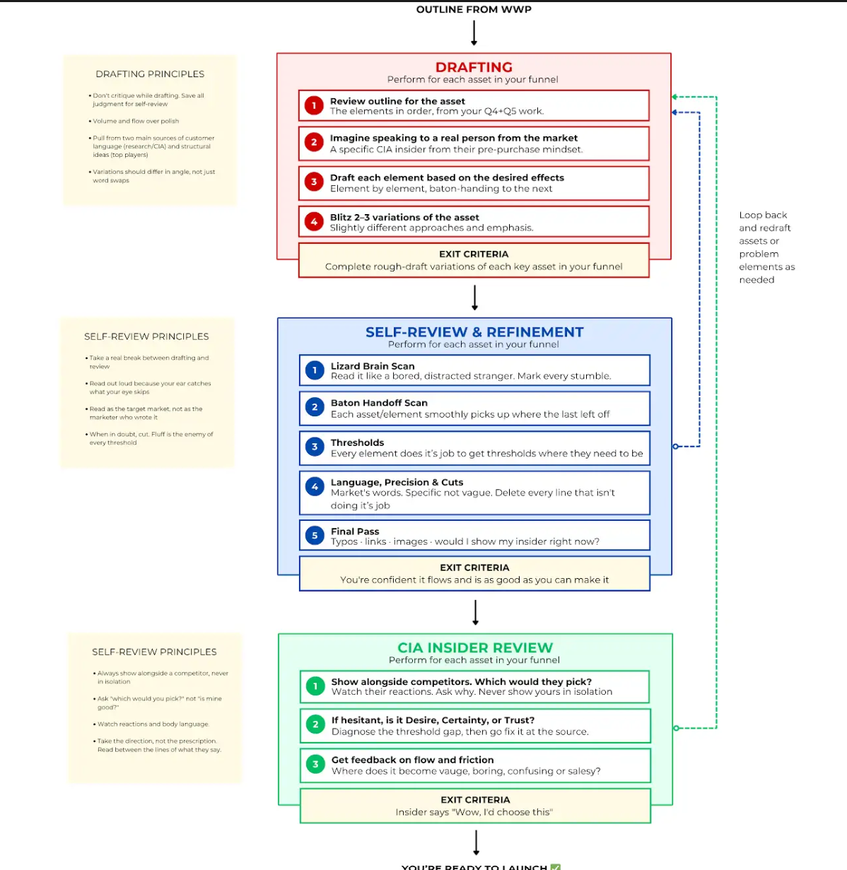

Click below to check the list of self review checklist:
Self review checklist

“

Scan 1. Lizard Brain. Read as Carol at 9pm.

You read each ad variation the way Carol would. Phone in one hand, half distracted. Variation 2 sounds like a copywriter. Too polished. You rewrite it simpler, closer to her voice.

Scan 2. Baton Handoff. Does each element pass to the next?

Variation 1's ad promises a feeling. The page picks it up in the first sentence. That one flows. Variation 4 promises something the page never delivers. You fix the opening.

Scan 3. Thresholds. Desire, certainty, trust.

Desire is held by the ad. Certainty is doing the work in the middle of the LP. Trust is the close and the offer. You check each one is in the right place. The desire line is good. Certainty is a little thin. You add one line with Carol's own words about following through.

Scan 4. Language Precision and Cuts.

A paragraph in the middle of the LP drifts back into describing the studio. Copywriter smell. You cut it entirely. You kill two adjectives that were there for rhythm, not meaning.

Scan 5. Final Pass. Read top to bottom as one conversation.

Ad to page to offer. One voice. One conversation. You read it out loud. It sounds like you're talking to Carol, not pitching her. Done.

Question 1/2
THE POINT OF SELF-REVIEW

You just caught three problems in your own drafts before showing them to anyone. What is the purpose of this step?

- To compare your drafts against three or four additional competitors you have not analyzed yet, in case there are stronger structural approaches you missed

- To catch the obvious problems yourself so you do not waste your insiders' limited time on things you could have fixed on your own

- To polish the grammar, formatting, and visual presentation so the insiders see professional-looking work and take the review more seriously

- To build your confidence in the drafts so you can explain and defend your creative choices when the insiders challenge specific elements

Answer no:2

CORRECT ✅

Insider time is too valuable to spend on problems you could have caught yourself.

____________________________________________________________________

FUN EXERCISE
Before you send anything to Megan and Carol, try this.

Write the worst possible version of this ad. The one that sounds like every competitor you audited. The one that would make Carol close the tab in two seconds.

Laugh a bit then carry on.

🛑 THE WALL 🛑

Self-review done. You schedule a call with both Megan and Carol for Wednesday.

You have drafts. You have your two insiders lined up. You could just show them your work and ask "what do you think?"

You already know what happens if you do. You get politeness. "Looks good to me." You get feedback that sounds helpful and tells you nothing about whether this wins in the market.

You need a way to pull something real out of fifteen minutes. Something that reveals preference, not collects opinions.

Below is our Professor Andrew’s third Comment:

“CIA INSIDER REVIEW

All right, if you've gone through, you've drafted it out, you've refined it, you've done the long, painstaking, money-making work of refining through this, you're reading out loud.

You imagined what a person's done.

You go to the point where you're like, yes, this is as good as I can make it.

I'm pretty confident that the stuff I have drafted is going to grab their attention and get these people to buy, so take them through the whole process.

Well, then you are ready for the CIA insider review.

Now, what you're gonna do here is you're going to, you're gonna cheat.

You're gonna cheat the game.

Every other business on the planet, they have to like throw their marketing out there and just hope it sticks.

And they do their little bit of research and they do their best and they just hope it stakes, but half the time it doesn't and they waste a lot of money.

You're gonna cheat.

You're gonna get your insider, your guy on the inside of the target market, to go through and review your stuff.

See how well it would catch his attention and help you tweak this.

So when you go to market, when you launch, your copy is closer to being perfect.

And you still will probably have to tweak a few things after launch, but, you know, get you there so much closer because you got this insider, someone on the, I mean, your man on the inside, helping you refine your stuff and and better tailor matching it to how the market thinks and desire stuff.

So, You're gonna go through and you're gonna, you're gonna give them comparisons.

If you just show them your copy, if you just say, Look, here's my landing page.

Does it look good to you?

They'll say, Yeah, 'cause they're not, they're just comparing it to nothing.

But if you have them compare your page against your three top local competitors, well, now that's a real choice.

Now they'll be able to tell you which one they like and then why, and why yours is the one or why yours isn't the one.

And that piece of feedback is way better than, yeah, I kind of like it, or yeah, I kind of don't.

It's gonna help you find more specific feedback.

So you're going to get your drafts and you're going to get some of your competitors and you're going to show them to your target mortgage side by side and get them to choose.

And then you're going to drill down on the reasons they give you.

Um, if they're hesitant, if like, if they're like, yeah, I think I don't know if I'd be willing to buy.

This is where you're gonna super zoom in and try and look at the thresholds.

You're gonna try and see if it's, like, whether or not they believe the idea, like, the thing is valuable to them or not, if they want the thing in the 1st place or if they believe that, or if they don't believe that this thing will actually work or they don't think that it's trustworthy, you're gonna try and zoom in on which of the thresholds is weakest because that's gonna give you some more clues.

Also, as you have them go through, the other thing you're going to want to try and do is get their feedback on the flow.

So if they read through and you're going to want them to tell you when it gets boring.

Like, hey, if you read this, it gets boring or confusing, just point to it and let me know.

And you're going to find those little points and reach week though.

Basically, you're gonna have them take a look at your copy alongside your competitors, make a choice, and then go back through your own stuff and give you a detailed review piece by piece.

And as you do this, there's two things you have to be aware of.

Number one, initially, they're not gonna want to give you feedback.

They not going to want to tell you why your page sucks. Or why your copy is dumb, because they're worried that, you know, to hurt your feelings, they don't know how who you are, how you're going to react to this.

They don't want Linda to feel bad or whatever.

And a lot of times people will be overly nice.

So one of the things I like to do when I sit down for one of these conversations is I'll start the conversation once we get into like the breakdown and I'll be like, listen, you know, I've done my best on this, but I don't think it's that good.

I think I'm missing a couple things.

Like, for example, I think the headline might be a little bit weird.

I'll kind of like pre-admit to some problems and you can just basically make something up.

Like, pre-admit to something you got questions about or have worries about.

That way they know that you don't think that this is like the best thing your ego super attached to it.

Anyways, you're gonna pre-empt it with that.

Then when they start to give you feedback and they say, well, they're always going to test.

Before they give you the full feedback, they're always going to be like, well, um, I think maybe kind of it's a little bad here because of this, and they're going to try really, really carefully to very, and like the least offensive way possible give you negative feedback. About your stuff.

Here's what you need to do.

When they do that, you have to tell them, thank you.

Oh, thanks.

I didn't even see that.

I wouldn't have been able to catch it.

And listen, I got tough skin.

I want this to work.

I appreciate you for telling me this.

Uh, it's, you know, it's always hard for people to like open up and telling this.

I promise like this is so useful.

What else do you see?

What else can we do to make this better?

And you actually, if you show them that you get excited, when they give you negative feedback and you show them that it's like you're looking to make it better, then they'll say, okay, it's safe to share my negative feedback and they'll start letting you in on some of the changes that need to happen.

They'll give you a more honest take on where it gets boring or where it needs to be changed or where it's not convincing or where it sounds salesy, for example.

So if you preempt it, you tell me you have tough skin, you tell me that you're just committed to make this happen.

You tell them that you've got a couple ideas of where it might be wrong.

And then when they do start to open up, you reward them and tell them thank you for it.

That's where, um, that's where you'll get them to actually open up and give you some information here.

You've got to do, you've got to do that or else they just, they won't, They won't.

They won't feel comfortable opening up to you.

And they're going to uncover some stuff. Some things that you didn't even see.

Their perspective from the inside is so much different compared to yours that you're a lot of times going to go back up and redraft certain pieces of your asset, re-review stuff.
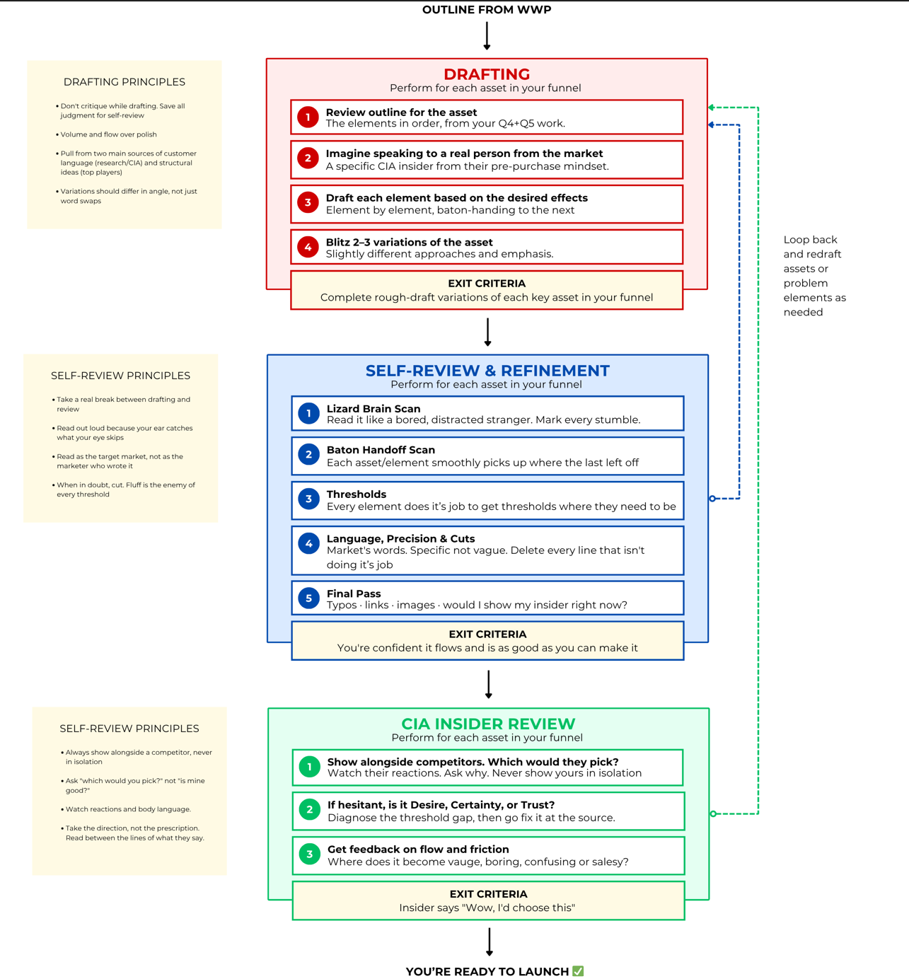
You're gonna go through and loop through the process again.

Another thing to keep in mind, I'm just, I want to cover this really quick, is you want to, you want to watch the reactions in their body language.

If possible, you want to do this in person or over a video call.

You want to watch their face as they read the copy.

You want to pay attention to when they tense up.

You want to see where they get confused.

You want to watch how they act and physically how they react, because they're going to tell you a lot with their body language that their words will, the words will tell you a lot, but their body language will tell you a lot, too.

You gotta pay attention to that.

So if possible, do it in person.

You also, you have to pay attention to what they say.

They might come up with, they might make suggestions that are, You have to be able to read between the lines.

So you have to listen to what they're saying, what they're not saying, you have to be able to drill down a little bit deeper.

It's a skill and you'll get better at it over time.

Initially, you'll get a lot just from your 1st conversations, but over time, you'll learn how to read between the lines of what they say.

So when they say it's boring, you'll you'll kind of know what that means actually.

Or if they say they're confused about this, you'll know that it's, and they say, this is confusing.

Maybe add 4 more sentences talking about this.

You'll know that really you should like show them a picture instead.

Like, you'll start to pick up these things and understand the like, they can show you where the problem is.

They won't always know what the solution is, but you can.

You'll take their words, you'll take their advice, you'll go put together new information, you'll make new tweaks, you'll create new things to create those effects in their minds.

And then you'll show it to them again.

And once you reach the point where when you show them your copy, when you show them this draft for an ad or for a landing page, say, wow, I definitely would choose this.

I click this over the competitors.

Congratulations, my friend.

You've pretty validated your marketing project.

Not only have you carefully engineered it, but you ran it through a target market inside her.

You've refined it made as good as you can, but you also got your guy on the inside to pre-validate this before you launch it in front of everybody.

You now know that it is, like, as confident, you're as confident as you can possibly be, that it's going to grab attention, it's going to convince people to get by. Is going to create all of the triggers and effects inside of their mind to get them from where they are now to where you want them to go, to get them to buy.

You've done that by going through a very simple process.

Now, this is a skill you guys are going to get better in this and faster this as time goes on.

Your 1st couple loops through this whole thing is gonna, might take you a little bit longer than you'd like, but as you get better, this, you'll be able to start to run this automatically in your brain.

You'll be able to go out and you'll be able to, like an engineer, create marketing systems to grab giant chunks of the market, but make sure you follow all 3 of these, make sure you're drafting, reviewing, you're doing your CIA insider stuff.

This is how you can get it as close as possible to being perfect before you launch so you can make a ton of money.”

***



Carol and Megan show up for the call on Wednesday and you dive in.

Step 1. Show your draft alongside competitors. Never in isolation.

Ads first. You pull up all your variations next to the best ads from the two strongest local competitors. Side by side on the screen.

You don't ask "what do you think?" You ask the real question: "If you were scrolling and saw all of these, which one would make you stop?"

Megan picks variation 1. The Monday framing. Carol picks variation 1 too but says variation 3, the curiosity angle, almost got her.

Neither of them even pauses on the competitor ads. "Those look like gym ads."

Choice revealed preference. You know which ones to test live.

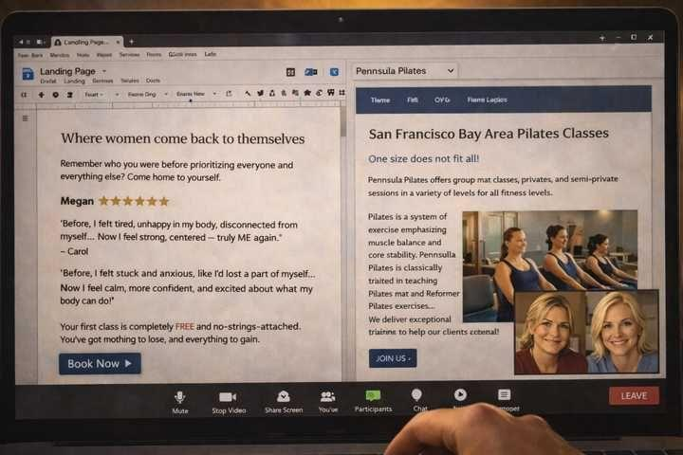

Step 2. When they hesitate, diagnose whether it's desire, certainty, or trust.

Landing page next. You show your page alongside both local competitors' pages. Megan reads all three. She barely scans the competitors. "Same thing as before. Schedules and credentials." She reads yours carefully. "Yours is different now. This one sounds like someone who was there."

Carol reads it. Pauses on the opening. Then pauses again halfway down.

You don't rush her. The pause is the signal. You ask: "Is that a I don't believe this is for me pause, a I'm not sure this will actually work pause, or a I don't know these people yet pause?"

Carol thinks. "The second one. I think I buy that this is for me. I don't yet buy that it'll actually work for someone like me."

Certainty. That's the scan you needed. You mark it and keep reading.

"This does not feel like it is about the studio anymore. It feels like it is about me>
I would have felt seen if I had read this back then."

Step 3. Get feedback on flow and friction. Not word choice.

Carol hesitates again on the booking section. You ask what's happening in her head right here, not what she'd change.

"What if I book and then get cold feet and don't show up?"

That's trust, not certainty. Specifically, trust that the no-show isn't a judgment. She didn't tell you what to write. She told you what she felt.

You take the direction and write the line yourself. "No commitment. No pressure. If you show up, Linda will remember your name. If you don't, she'll check in."

Carol reads it. "Okay. That actually helps."

Directional, not literal. You asked about feeling. You did the edit.



Final confirmation. You show them the complete funnel one more time alongside the local competitors.

Megan: "If I had seen this eighteen months ago I would have called the same day."

Carol: "I would click yours. Also this kinda makes me want to try it now."

Neither of them would click either competitor.

Question 2/2
WHY COMPARE

You showed Megan and Carol your drafts alongside the two strongest local competitors instead of just asking "what do you think of this?" Why?

- Comparing against competitors helps you identify specific design elements and visual details you should incorporate into your final version before launch

- Seeing the competitors first makes your version look better by contrast, which builds the insider's confidence in what you built and gives you more positive feedback to work with

- When they choose between real options instead of evaluating yours in isolation, their reactions tell you what actually wins and why, not just what seems nice

- It shows the insiders that you have done your research, which builds their trust in your process and makes them more willing to give detailed and honest feedback

Answer no: 3

CORRECT ✅

"I would click yours" is more useful than "that looks nice." Choice reveals preference.

Preference is what matters in the real market.

That is why you never show your work in isolation.
___________________________________________________________________

You close the laptop. Look at the desk.

A full funnel. Mapped. Drafted. Revised. Two insiders who'd click yours over every local competitor and can tell you exactly why.

Everything you came here to build is on the page.

And yet.

Carol on your video call is not Carol in her kitchen at 9pm with a phone in her hand. Megan on a screen is not Megan scrolling between meetings. Everything that felt settled in the insider room is about to meet people you've never talked to.

You picture the first ad going live. The first scroll. The first click. You can't quite tell yet if you're nervous or just ready.

💬 COMMUNITY CHALLENGE 💬

You just built a full funnel from research to validated draft.

Find a local business in your area that is doing a good job of catching your attention. Maybe an ad that stopped your scroll, a page that pulled you in, or a storefront that made you curious. Post what you found and what they did right.

Go post your answer in the Newb Chat.

PS - The students who do these exercises tend to perform best when there is real money on the line.

🏆 ACT 3 COMPLETE 🏆
You can now take a blank page and turn it into a validated funnel. You can engineer each element around the right threshold, model it on a top player recipe, and structure the handoff so the whole thing flows like one conversation instead of three separate ads.

Carol's shift from "it still kind of feels like it is about the studio" to "it feels like it is about me" is your proof. You built that shift on purpose. That is the skill.

The plan is ready. What happens when it meets reality?

SKILLS UNLOCKED👇

☑️ Apply the Winner's Writing Process

☑️ Map where they are now (awareness + attention)

☑️ Choose the action that matches the biggest threshold gap

☑️ Identify the three thresholds (certainty is the gap)

☑️ Map the mental chain (Q4) and the trigger for each step (Q5)

☑️ Reverse engineer the top player funnel element by element

☑️ Draft 3-4 ad variations + LP + offer

☑️ Self-review as the avatar

☑️ Run CIA insider review until both pick yours

COMING NEXT:

ACT 4: THE MOMENT OF TRUTH
The plan is ready. What happens when it meets reality

self_review_checklist

Self-Review
Checklist
Run this after every draft, before showing it to anyone. Your drafting brain is not the brain your reader uses. This checklist forces you to switch modes.
Read as the target market. Not as the marketer who wrote it.
Take a real break between drafting and reviewing. Come back harsh.
Lizard Brain Scan
Read through your copy quickly, the way a bored, distracted person would. Mark every place you stumble.

☐ I read the first 3 seconds of my ad / first screen of my landing page out loud. A stranger could immediately tell what this is about.
☐ Nothing in the first scroll requires effort to understand. Cognitive load is low.
☐ I read the entire piece out loud. Every sentence I stumbled over is marked for rewrite.
☐ Every place my attention drifted is marked. If I got bored, the reader will close the tab.
☐ Nothing sounds like "marketing speak." It sounds like a person talking to another person.
Baton Handoff Check
Read from one asset to the next. Does each piece pick up exactly where the last one left off?

☐ The landing page headline matches the mental state the ad left them in.
☐ Each section of the page flows into the next without a jarring shift.
☐ The CTA feels like the natural next step, not a surprise.
☐ If I read the ad, then the landing page, then the offer back to back, it feels like one continuous conversation.
Threshold Check
Go through your copy section by section. Label what each section is doing. If it does not have a clear job, cut it or rewrite it.

☐ I can label every section with the mental effect it is supposed to create (increase desire, build belief, raise trust, lower perceived cost).
☐ There are no sections without a clear job.
☐ I have addressed the weakest threshold (the one with the biggest gap) with enough firepower.
☐ I have not accidentally lowered a threshold somewhere (e.g., a claim that sounds too good to be true tanks belief, a typo tanks trust).
Language and Precision
Check that you are using the market’s words, not your own.

☐ The pain and desire language comes from real research or CIA interviews, not my guesses.
☐ I am not using vague words ("feel better," "get results," "high quality") where I could use specific ones.
☐ I checked for the "burned out vs. invisible" problem: am I using the right category but the wrong word?
Final Pass

☐ Typos and grammar checked.
☐ Every image, button, and link works.
☐ I would not be embarrassed showing this to my CIA insider right now.
☐ If the target market read this, they would feel like someone who understands them wrote it.
Your first drafts will always need this. The gap between mediocre and great lives in the revision. Do not skip it.

Gearing Up For Launch


Studio. Early morning before the first class. You walk in with everything.

Three ad variations. One landing page. One offer page. Each one already tested with real people in her market.

You are not brainstorming ideas anymore. You are presenting a finished package backed by evidence.

Question 1/2
GUT CHECK

You are about to show Linda your three ads, a landing page, and an offer. The whole package.

Before you go in, predict it. What is the one thing she is most likely to push back on?

- The free discovery class. She'll worry about giving away revenue she does not have to spare

- The cost of launching new ads after the last three things she tried did not work

- The "Monday" line in the ad. She'll think it sounds too negative for her brand

- Why this is different from the marketing she has already tried, since the last three rounds went the same way

Answer no: 4

CORRECT ✅

She has tried things. They failed.

She is not going to get excited about a new package until she understands why this time is different.

Hold that prediction. You will see it tested in a few cards.
__________________________________________________________________

You walk Linda through the ads first.

Variation 1: the "Monday" framing. You tell her where it came from. Carol's exact words about telling herself she would start on Monday for two years. The ad does not mention the studio. It does not mention pilates. Its only job is to stop the scroll and get the click.

Variation 2: the identity an
gle. Megan's words. "Not the type of person who does pilates." Same rule. Name the feeling. Earn the click.

Variation 3: the curiosity hook. Opens a loop the landing page closes.

You watch Linda hear Carol's exact words come out of your mouth.

The Monday line is not a clever ad you wrote. It is a sentence Carol said in week 5 of the interviews that you wrote down and never let go of. The identity line is Megan's. The curiosity hook is built off the question Carol asked you near the end of her call.

Every line in this deck has a fingerprint on it. None of them are yours.

The landing page. You walk her through how it works.

The opening names the feeling instead of describing the product. The middle dissolves the certainty objection using Megan and Carol's own words. The social proof section uses psychographic before and afters. Women who felt the same way before they started.

Every paragraph has one job. Every job maps to the baton handoff.

The offer. Free discovery class.

You explain why. Carol does not need a discount. She needs to believe this time will be different. Zero commitment gets her in the room. Once she is there, Linda's superpower, the noticing, the texting, the remembering, does the rest.

You show her Megan and Carol's responses to the final version.

Megan: "If I had seen this eighteen months ago I would have called the same day."

Carol: "I would click yours now."

🛑 THE WALL 🛑

Linda reads their responses. Then reads them again.

Then she puts the page down.

Everything you have shown her is built on real evidence. But evidence does not erase the memory of the last three things that did not work.

She is about to push back. You are about to find out if you are ready for it.

Question 2/2
HANDLING THE PUSHBACK

Linda says: "I have heard versions of this before. The TikTok girl told me she had a system. The agency told me they had a system. Why is this different?"

- "Trust me. The research is bulletproof this time. You just have to take the swing."

- "Look at the spend. We are running a fraction of what the agency cost you. The downside is small."

- "Let's run a small test for two weeks. If it does not work, you have lost almost nothing."

- "Every line in this deck was not written by me. It was pulled from your customers and validated by two of them. The TikTok girl was guessing. The agency was guessing. We are not."

Answer no: 4
CORRECT ✅

Every word came from her market and was tested by two real people in it.

That is not a pitch. That is a paper trail.

That is what dissolves the memory of the last three failures.
_______________________________________________________________

You walk her through the logic.

The ad exists because of Carol's framing. The landing page exists because of the certainty gap both insiders confirmed. The offer exists because direct experience is the only thing that answers "will I follow through." The structure mirrors the Portland studio because two real people in her market said they would choose it.

Every decision traces back to what a real person said. It stops feeling like your opinion and starts feeling like evidence.

Linda is quiet for a moment. Then she starts adjusting.

She knows things about her business you do not. Scheduling constraints. Pricing details. The best time to run the discovery class. She makes a couple small refinements.

She is not questioning the strategy. She is making it fit her operation.

"I have a friend who does websites. I can send this over to her this week. And I still have that Facebook ad account from the last time."

She has already started planning.

"When can we launch?"

The Final Reckoning



Tuesday morning. Three ad variations go live. One landing page. One offer.

The insiders picked their favorites. The market will decide.

You are checking your phone more than you would like to admit.

Wednesday. 4 link clicks. 2 form starts. No completions.

Variation 1, the Monday framing, is getting the most clicks. Variation 2 is flat. Variation 3 is getting engagement but fewer clicks.

You stare at the numbers. You remind yourself: it has been one day.

Question 1/2
HOLD OR PIVOT?

Wednesday night. Linda texts you.

"Is this normal? Should we change something?"

You stare at the message. The numbers do not know about your process. The numbers do not care.

What do you tell her?

- "Give it two more days. The data is too early to read. The Monday framing is already pulling clicks. We need conversion data before we touch anything."

- "Yeah let's swap variation 2 for something punchier. I'll have a new ad to you tonight."

- "Let's add a discount on the discovery class. People probably aren't pulling the trigger because the offer feels too good to be true."

- "Let's pause variations 2 and 3 and put all the spend behind variation 1, since it's the only one getting clicks."

Answer no: 1

CORRECT ✅

4 clicks is not enough to be a signal. It is just noise at this point.

You touch the funnel now and you destroy your ability to read it.

Your job at this stage is to be the calm one in the room.
_______________________________________________________________

You check again on Thursday.

11 discovery class bookings. Most from variation 1.

You read it three times.

By the end of week 2 you sum up the data

4 new paying members. From one funnel.

Variation 1 won because it used Carol's exact framing. The landing page converted because it spoke to the person instead of the product. The 4 membership conversions happened because Linda's personal follow-up kicked in after the first visit.

Every result traces back to a specific decision you made based on specific words a real person said.

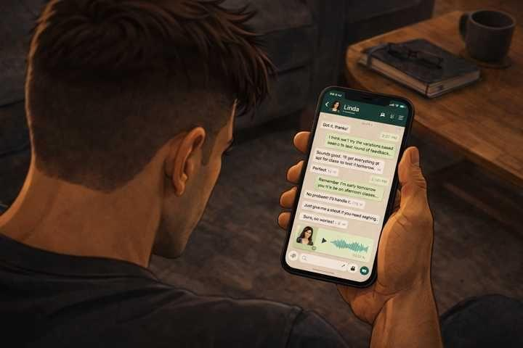

Linda sends you a voice memo at 11pm. A little emotional. Thanks you three times.

"I cannot believe I almost tried random TikTok posts."

Question 2/2
WHY IT WORKED

The funnel worked. But why did it work?

- The results came from sustained visibility and consistent daily posting over two full weeks, which built enough local awareness and familiarity to generate bookings

- Running three ad variations simultaneously gave the social media algorithm enough data to automatically optimize delivery toward the highest-converting target audience

- Every element of the funnel was built from real research, validated by real insiders, and designed around the specific barrier the market described

- The professional design and layout of the landing page made the studio look significantly more credible and trustworthy than the other local competitors in her area

Answer no:3

CORRECT ✅

Intelligence, validated before launch.

That is the only thing that separates a real funnel from a guess.

Now you have run it once with the narrative walking beside you.

The Proving Ground is next. Same process. No narrative. A business you have never seen before.

________________________________________________________________________



A few days later. You review all that you accomplished.

When most people look at a struggling business, the instinct is to fix the surface. Better content. More consistency. The right platform. Bigger budget.

The research showed something different.

The platform was not the problem. The consistency was not the problem. The problem was that nothing Linda had written was aimed at a real person with a real feeling.

The market existed. The desire existed. The gap was between what Linda was saying and what the women out there actually needed to hear.

Most people who looked at Linda's Instagram that first morning would have told her to try TikTok.

You did not. Because you knew the problem was upstream of the tactic.

You learned to see that gap.

You will find it in every business you work with. It is always there. The process is how you close it.

Full checklist:

Act 1: Identify the problem. Build target buyer profile. Research market voice. Fill template with real language. Audit local competitors. Study top players. Identify the mismatch.

Act 2: Source insiders. Plan the interview. Run CIA interviews. Extract precise language. Test funnels side by side. Identify the certainty gap.

Act 3: WWP big picture. Where they are now. Three thresholds. Action and experience. Baton handoff and top player recipe. Draft variations. Self-review. CIA insider iteration until confirmed.

Act 4: Present finished package. Launch. Analyze results and trace back.

Campaign complete.

Below is our Professor Andrew’s Comment:

“WHAT COMES NEXT?
“
All right, so you've completed the story.

You've gone through, you sat down with this Linda character, you walked through all the big mistakes she was making, you found out about a Target market.

You learned the deep insights into how some people were being successful in that market, how others weren't, you were able to find some good strategies to use.

You got insiders and used the CIA method to get advanced inside knowledge.

Not only that, but then you went off and did the winners, writing process, engineered, reverse engineered, the marketing strategy would get attention from the target market, and then you use that to draft out and create marketing assets that actually worked, that produced the correct effects in the correct order, and got people to come and imply.

Now, the point of this story and the lessons here is to give you an introduction into the basics.

You now know everything you need to know, by...

Like, my goal with this course, with this boot camp, was not to give you a fish, like, but to teach you how to fish.

You've learned how to fish.

You've learned how to reason through, how to work, how to approach a market, how to find an advantage, how to find an opportunity, how to understand the target market.

You've learned how to reverse engineer, and then engineer successful marketing assets, pick the right funnels.

You learned how to do all of this.

Now, as you go through the rest of the course, you're going to learn more and more.

But at this point, my friend, you're ready to land your first client.

You're ready to get started with your first client, go through the same process.

You have everything you need to know, and you're gonna get extra resources and extra cheat coast to fill in the gaps as you go forward.

You have the chat to help you.

You basically have learned what you need to learn.

A couple of things I want to give you, a little bit of advice before you jump into this.

Number one, there, in the next few slides or the next few pieces of the course here, you're gonna see, there's a challenge, an optional challenge I give you.

It's gonna give you an opportunity to practice some of the concepts that you learned, but without as many of the training wheels as you experience inside of the boot camp.

You're actually gonna sit down and go through some of these processes, not all of them, but some of these processes, to get a little more familiar, and to get a little more confident before you go and reach out to clients.

So to give you a little bit more experience yourself.

So that's gonna come up next.

I highly recommend you do it.

If you're up for the challenge, it's gonna be very rewarding and we'll give you a, give you a leg up over everyone who doesn't.

Also, the byproduct, or sort of the outcome of doing this particular challenge, you're gonna walk away with, like, a usually a very specific idea you can use to help businesses grow, that will oftentimes lead your 1st client.

So I highly recommend you guys take this next challenge as you move forward.

But I also, my final little piece of advice before you carry on in your journey here and guy dive into the challenge and getting your clients and all that fun stuff.

I highly recommend you make lifelong learning about this skill set a priority for you.

You understand the basics, sure, but there are levels to this game.

There are nuances to understanding people and knowing how to influence them.

There are skills you can develop, there are methods of, and methods of communication and, and selling that you can learn that will make you better and better.

This is time goes on.

And if you just take the knowledge that you have right now, it's sure you'll be able to go land a couple of clients and get a couple of projects under your belt.

But if you want to continually upgrade in this game, if you want to make more, more money, conquer bigger, bigger target markets, have bigger and better clients or launch your own businesses.

I highly recommend you take time to use the resources in the campus, whether that's the future lessons, that you'll see in the course, or the puzzles and the dojo cases, and the conversations in the chat, the calls to constantly enhance your skills.

Because if you constantly get better and better and better, the opportunities you'll be able to conquer get better and better and better too.

The ability to make money gets better and better and better.

You're gonna get paid ultimately as an individual based on your skill.

You've just developed a huge amount of skill and an experience via this boot camp story and the challenges that you've gone through, I recommend you continue to double down on that, compound on that, add to that, continue to get better and better so you can become a master of the universe, ready to parachute, into any target market on the planet, show up, find a way to win, and harvest money, because you understand the process.

You've developed skill.

You become that guy.

So I want to give you some congratulations for finishing this part of the course.

Some advice as you carry on.

Now's time for you to take this information and go out and get paid.”

💬 COMMUNITY CHALLENGE 💬

You just ran the full process from research to real results.

Find a local business in your area that is struggling to get attention or convert customers. What are they getting wrong? What would you fix first? Post the business and your diagnosis.

Go post your answer in the Newb Chat.

PS - This is going to set you up for one of your first sales opportunities

🏆 CAMPAIGN COMPLETE 🏆

You just ran the full Linda Campaign with the narrative walking beside you. Stop and notice what changed.

You can now sit across from any local business owner, look at their marketing, and name the gap between what they are saying and what their market needs to hear. You can run a CIA interview that gets past the polite answer. You can write copy that uses your audience's language instead of your own. You can defend every line in a deck with a real customer's fingerprint on it.

Most marketers never close that loop. You just did.

Now it is time to do it without the training wheels.

SKILLS UNLOCKED👇

☑️ Find ways to grow any business on the planet by reading the gap between their marketing and their market

☑️ Run a CIA interview that gets past the polite answer

☑️ Pull the precise emotional language a market will respond to

☑️ Reverse-engineer a winning funnel into a tested skeleton you can fill

☑️ Write copy where every line traces back to a real customer's words and drives them toward the sale.

☑️ Defend any creative choice with evidence instead of opinion

COMING NEXT:

The Proving Ground
Same process. Different business. No narrative. You run it yourself.

